Mission

Posted March 26, 2009 · Report post
I am still pondering my period(ish) medicine sea chest for holding all my potions and instruments and I thought those of you with experience in other sea-going chests might be able to help me out. Note that there are no known extant medicine chests from anywhere even near period. The best we have is a drawing from William Clowes which was first printed in one of his books in 1588. You can see it below.
There are a number of problems with using this particular chest as a template for a sea surgeon's medicine chest IMO. First is the date, which is about 100 years before period. For the time being, we'll leave that aside. Second is the size. Of course, it is almost impossible to say the size since there is no scale. I have seen a photo of one that was built by someone using this sketch as a model. (This picture is from this site.)
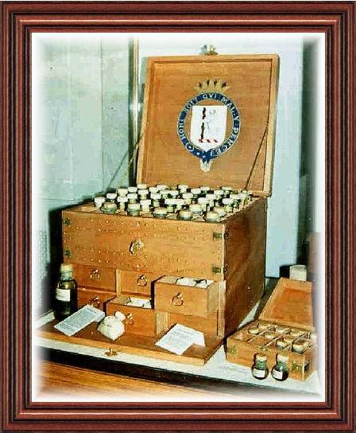
I would guesstimate that this is no bigger than 2' or 2.5' square, and possibly smaller. What is wrong with this sizing is that it would not fit one of the key instruments that Woodall implies was stored in the chest - the large bone saw. According to Alex Peck Medical and Surgical Antiques, who sold a saw almost exactly like the one Woodall depicts in his book The surgions mate, the saw would have been about 25" long. Such an instrument would not fit in the box Clowes has shown. The third problem I note is the design of the drawers. In the reproduction, you'll notice that the drawers are shown filled with bottles. However Woodall -who not only wrote the book on stocking Surgeon's Chests, he did so for the East India Company for several decades as well as for the British Royal Navy for several years - explains that the Saw and most of the other capital surgical instruments went into the chest. So these drawers appear to me to be impractically designed to house the sort of materials that the primary source we have on the topic says they housed.
It is my considered opinion that this chest was for land-based surgeons, which is sort of supported by the doodlings Clowes has shown of men walking around in the background along with buildings. Land-based surgeons would have more ability to store multiple chests and boxes and would be able to purchase those things which they might need if they did not have them. Sea surgeons must take everything they need with them. This much for Clowes chest.
My thought is that a surgeon's chest would be long and somewhat like a seaman's chest, except with drawers. Woodall explains that some drawers contained some instruments (although this is not well explained by any stretch of the imagination). I conjecture that it would be like a machinist's chest:
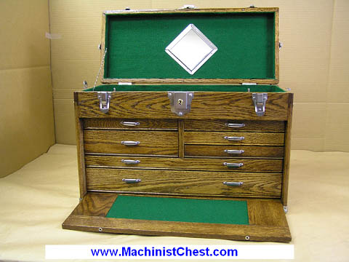
...although perhaps without the front as it is shown. (The front is shown folded into the very bottom of the above chest. It can be partially pulled out to serve as a shelf for the machinist as well as being removed and placed into a slot along the bottom of the chest to enclose all the drawers.) On the other hand, Clowes' chest sort of looks like it might have a front like that, so I could be wrong.
What are the cognoscienti's thoughts? I have some notes relating to the surgeon's chest that I may bring up in another post, but for now I'm interested in ideas on type of wood, approximate size and appropriate hardware.
Since these surgeon's chests were created by the Apothecaries for the Navy, I wouldn't think they would be of the fine quality of a captain's desk. But because they were for surgeons (warrant officers - and necessary ones at that), I wouldn't think they would be of the rough timbers of a lowly seaman's chest. I would expect the hardware would be of the common sort, but not the base sort.
Any ideas?

Quartermaster James
- 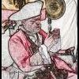
- Member
Posted March 26, 2009 (edited) · Report post
Have you seen this one: Naval Surgeon's Amputation Kit?
Yes, it is 100 years late but it does raise the question that perhaps tools and medicines were kept in different chests? Also, Goddard seems to think that little changed from Woodall's to Napoleonic times (The navy surgeon's chest: surgical instruments of the Royal Navy during the Napoleonic War).
Another maritime medicine chest.
Edited March 26, 2009 by Quartermaster James

Matty Bottles
- Member

Posted March 26, 2009 · Report post
Have you tried searching on antique auction sites? They frequently give the provenance and dimensions of the pieces up for auction.

Quartermaster James
- Member
Posted March 26, 2009 (edited) · Report post
Bloody Jack Madd said:
Have you tried searching on antique auction sites? They frequently give the provenance and dimensions of the pieces up for auction.
Like this? Trinity Marine
Edited March 26, 2009 by Quartermaster James

Matty Bottles
- Member
Posted March 26, 2009 (edited) · Report post
Quartermaster James said:
Bloody Jack Madd said:
Have you tried searching on antique auction sites? They frequently give the provenance and dimensions of the pieces up for auction.
Like this? Trinity Marine
Well, just like that, yes.
Or this:
http://www.artfact.com/auction-lot/a-surge...98-c-1cbaa50524
http://www.artfact.com/auction-lot/a-part-...-8-u-8f2dfe123e
Those are both 19th century, but it's a start.
EDIT: Wow, James, your find is AWESOME. Much better than mine. Mission, I think that's a pretty good start.
Edited March 26, 2009 by Bloody Jack Madd

Capt. Sterling
- Member

Posted March 26, 2009 · Report post
Mission said:
...although perhaps without the front as it is shown. (The front is shown folded into the very bottom of the above chest. It can be partially pulled out to serve as a shelf for the machinist as well as being removed and placed into a slot along the bottom of the chest to enclose all the drawers.) On the other hand, Clowes' chest sort of looks like it might have a front like that, so I could be wrong.
What are the cognoscienti's thoughts? I have some notes relating to the surgeon's chest that I may bring up in another post, but for now I'm interested in ideas on type of wood, approximate size and appropriate hardware.
Since these surgeon's chests were created by the Apothecaries for the Navy, I wouldn't think they would be of the fine quality of a captain's desk. But because they were for surgeons (warrant officers - and necessary ones at that), I wouldn't think they would be of the rough timbers of a lowly seaman's chest. I would expect the hardware would be of the common sort, but not the base sort.
Any ideas?
The front (bit used as a 'shelf') would fold up and lock in place to obviously to keep the drawers in place... from the look of the cut in the first picture, the shelf does not look able to slide in under the drawers for storage. What is interesting to me is that in the drawing you posted there is a square on the side. If the drawers were not deep, perhaps there could be space beneath and behind them for stowing tools... although the drawing does show a lot of detail as to hinges and such and there does not appear to be any such devices regarding the square... so that could be just decorative... I have seen exterior drawers in a captain's sea chest from 1675 up in Salem and yet, there was SUPPOSE to be space behind the drawers like an ordinary chest... or so I was told by the museum... who STILL hasn't sent the pictures they keep promising me... sigh...
And then again, why not have one chest for tools and one specifically for medicines..??

Quartermaster James
- Member
Posted March 26, 2009 (edited) · Report post
Capt. Sterling said:
What is interesting to me is that in the drawing you posted there is a square on the side.
I believe that's the trap door from which the homunculi pictured in the lower right emerge.
Edited March 26, 2009 by Quartermaster James

Matty Bottles
- Member
Posted March 26, 2009 · Report post
That could also just be of panel construction.

Quartermaster James
- Member
Posted March 26, 2009 · Report post
Bloody Jack Madd said:
That could also just be of panel construction.
Yes, but on the left side of the illustration you can clearly see a larger homunculus emerging from the chest as if he was being extruded a la Play-doh Fun Factory.

Cascabel
- Moderator
Posted March 26, 2009 · Report post
Ya know.....
The whole problem with using these old woodcuts and period illustrations for reference is that they are generally terrible for judging size and proportion. I think we can be reasonably sure that the chest depicted in the picture was not really waist high, with drawers big enough to put an entire man's leg into, as the picture would suggest judging by the character resting his hand on the open lid. I also strongly suspect it was not actually built in the cock-eyed fashion shown in the woodcut.
You then have to fall back on using the old illustrations as a vague guide to general appearance. It becomes a judgement call on what would actually work and be practical. I think we can reasonably surmise that these surgeon's chests were custom built to the individual surgeon's needs, rather than to an "official" pattern.
>>>>> Cascabel

Dutchman
- Admin
Posted March 26, 2009 (edited) · Report post
hey mate- some things i've learned over time and notes from roy underhill. even though the boxes would have been standard design, they would still be well made. the wood needed to make a strong enough box would not have been cheap and only entrusted to master craftsmen to build- not apprentices. Being a master craftsman, the chest would have been his calling card. more than likely there would have been a couple of contracts for these- even if there was not, various carpenters within one shop would still have tried to one up each other.
now out of the contract and expanding on cascabels post- boxes were custom made for the owners needs. so you cannot find a period syrgens box, look at any sort of tradesmans box- caprenter, mason, gunsmith... each box is designed to fit that owners tools. If there were a surgeon on board a merchant vessel, would his supplies be the same as his naval counterpart?
Edited March 26, 2009 by bbcddutchman

Mission
- Admin
Posted March 26, 2009 · Report post
Interesting points raised with some great links. Keep 'em coming, I was not aware of some of those sites!
There are many things I do know about the surgeon's chest that I did not state in the original lengthy post that might be worth noting now.
First, as I understand it, the practice of medicine began undergoing sweeping changes starting around the early 1740s. Note that things during this period changed much more slowly than they do today. It seems from my reading that these changes continued slowly for about the next 100 - 150 years. (Yep, you read that right.) However, as a result, items found from the Napoleonic period are not necessarily going to be representative of what would have been around during the GAoP.
_____
Second, for surgeons of the East India and BRN, the surgeon's chests were standardized by the organizations who made them.
“Early in 1703 the Society [of Apothecaries] approached Navy Office with a view to obtaining the monopoly of all naval medical supplies other than the surgical chests provided from Surgeon’s Hall. If this were approved, economies could be effected, better control over quality and quantity exercised and supplies ensured.” (John Keevil, Medicine and the Navy 1200-1900: Volume II – 1640-1714 p. 272)
They may have varied by lot and year, but I would at least expect the design would be fairly consistent during the GAoP. (This is guesswork on my part, however. As I said, according to Keevil, we have no example of an actual original surgeon's chest from this period.) However, Woodall purportedly redesigned the Surgeon's chest and then detailed most of the instruments that were to go into it in his book, The surgion's mate which would have been around during period according to most accounts.
“[Woodall] addressed the problem of poorly stocked ships by redesigning the surgeons’ chests and implementing a system of checking each chest and sealing it before it was brought onboard.” (Glen Hazelwood, , “John Woodall: From Barber-Surgeon to Surgeon-General,” Proceedings of the 12th Annual History of Medicine Days, March 2003, p. 120)
Now, as to what a surgeon might have if he were not entering into the BRN or the East India Company, it would be impossible to say. However, most surgeons who went to sea did so because they were young, poor and inexperienced. The chests were very expensive to purchase outright, so they likely would not have been able to do so. Still, it could be argued that a ship owner might purchase a custom-made surgeon's chest that would differ from those given by the BRN or the East India Company.
_____
Third, Woodall suggests that everything was kept in the same chest.
“The Surgeon’s Chest
Even the smallest ship must have carried a massive wooden iron-bound chest to contain Woodall’s long list of items. Presumably the salvatory of six to eight ointments, the plaster box with its basic first-aid kit and the barber’s case were kept apart. The latter was the mate’s responsibility who, in addition to equipment for trimming and shaving, was provided with an ear-picker, paring knives for corn cutting and some dental implements. It is unlikely the chest would accommodate medical, pharmaceutical and nursing paraphernalia such as cupping glasses, blood porringers, dishes, pots, funnels, mortars, pestells and two sets of scales, one to weigh ounces and one grains; nor splints, bandages, lanterns, tinder-boxes, ink, quills and the brass pail in the close-stool!” (John Kirkup, prologue to The Surgions Mate by John Woodall, p. xvii)
(Say, I just noticed something... What does he mean by iron bound?)
And, for reference and my own re-education, another description from his intro (Kirkup is my favorite author on GAoP medicine.)
“The account of ‘Medicines Physicall and Chirurgicall’ (p. 40, from The surgion's mate) discusses some 270 items of vegetable, animal and mineral origin; according to the folding plan inserted in the 1639 edition, each medicine is placed specifically in the upper, middle or lower part of the chest, although Woodall left the middle part ‘to the Surgeons experimentall ordering and view.’ The plan divided the upper and lower parts into 170 named compartments and thus the middle had to accommodate at least 100 items. The editor [Kirkup] has failed to trace, either a naval chest of the period or, a contemporary illustration closer in time than the 1588 military chest of William Clowes. Unlike the latter chest, one can conclude the East India Company’s chests consisted of four layers, the topmost within the cover of the lid containing instruments whilst the remainder are given over to pharmacy.” (Kirkup/Woodall, p. xviii)
And I could go on (and on an on) with references, but for the time being I'll spare everyone.
_____
So from this I got a wood chest (apparently iron bound?) with four layers and 170 little compartments for the medicaments.
I still wonder what sort of hardware. I am not inclined to accept that Clowes' chest holds the key to that one. What was common on middling chests during the GAoP?

Mission
- Admin
Posted March 26, 2009 · Report post
Oh, and one other interesting quote - to explain Woodall's involvement with the creation of BRN surgeon's chests.
“The year 1626 was noteworthy both for medical reform and Woodall’s pocket; firstly the Privy Council decided to pay the Barber-Surgeons Company fixed allowances to furnish medical chests for both the army and the navy, and secondly the company requested Woodall to supervise their provision, in addition to his long-standing commitment to the East India Company chests. As a result he wrote, ‘myselfe had the whole ordering, making and appointing of His Highnesse Military provisions for Surgery, both for his Land and Sea-service,’ (Epistle-Congratulatory, 1639) inducing him to extend the appeal of this later edition to military, naval as well as merchant marine surgeons (Frontispiece).
Despite dismissal as surgeon-general to the East India Company in 1635 for economy reasons, he retained a monopoly of supplying the Company’s medical chests until 1643, the year of his death at about 73 years of age, presumably in London. There is no evidence of a prolonged illness although when 69 he maintained that poor sight and impaired memory prevented him from writing additional matter for The Surgeons Mate.” (Kirkup/Woodall, p. xv)
This is, of course, about 50 years before GAoP, so even it may not be accurate to period. However, Woodall has one of the few references to the making up of the Surgeon's Chest other than obscure government naval notes, so I don't have much else to go on.

Dutchman
- Admin
Posted March 26, 2009 · Report post
iron bound- wrapped in iron strapping and corner angles. this is done to support potentially weak joints on boxes know to be carrying heavy loads and is also used as security for valuables- such as medicines.

Fox
- Moderator
Posted March 26, 2009 · Report post
Not a surgeon's chest, but it might give you some food for thought:

One day I'll get round to making one of these. It's an officer's chest (42 cm long, 29 cm tall) recovered from the wreck of the Swedish ship Kronan which sank in 1676.

Patrick Hand
- Moderator
Posted March 27, 2009 · Report post
Quote
It's an officer's chest
I'm going to sound sooo dang stupid.... but what would an officer need that many drawere for in a small chest?.... Ok the portable writing desk also had a buncha drawers..... I'm sure if I only had so much space, I could fill the thing up with stuff also....
A navigator would need a safe place to keep all of his stuff, but hummmm that many draweres.... unless they got filled with other stuff....
Sure it would be handy.... but something about it has me wondering......

Fox
- Moderator
- .
Posted March 27, 2009 · Report post
They found 54 individual items in the chest, including navigational tools (some of which are pictured), an ink well, pipe cleaner, coins, a pen, and a seal. If you look at the dimensions it's not that big a chest that it would take long to fill.

Mission
- Admin

Posted March 28, 2009 · Report post
Thanks Ed. It would appear that the drawer pulls with the hoops were popular for sea item chests based on your pic and the one offered by Clowes. As the medicine chest must also have several small drawers in the body that is probably a good model.

Fox
- Moderator
Posted March 28, 2009 · Report post
You're very welcome. I posted it for the construction details, so I'm glad you got something from it.

michaelsbagley
- Moderator
Posted April 13, 2009 · Report post
It's not a reference to construction (really), nor is it made out of wood.... But I thought this was on topic and interesting enough to warrant popsting. (I found it while looking for info on a different style of box)
From HERE from a facsimile copy of the London Gazzette from 1685. Some editting has been done on my part as these are done with horrible optical character recognition software that produces tons of spelling errors.
Quote
Lost on Saturday the 12th of this Instant, between Blackwall
and Stepney, a plain Silver Chyrurgions Box, with a
pair of scissars with silver Bowes and broke at the points, and a
pair of Steel Forceps, with several other Chyrurgions Instruments
in the laid Box. Whoever gives notice of it to Mr. Da
Kaines a Goldsmith without Bishopsgate, or to Brown Johns by *
Ludgate, shall have Ten shillings reward

Mission
- Admin
Posted May 11, 2009 · Report post
michaelsbagley said:
It's not a reference to construction (really), nor is it made out of wood.... But I thought this was on topic and interesting enough to warrant popsting. (I found it while looking for info on a different style of box)
From HERE from a facsimile copy of the London Gazzette from 1685. Some editting has been done on my part as these are done with horrible optical character recognition software that produces tons of spelling errors.
Quote
Lost on Saturday the 12th of this Instant, between Blackwall
and Stepney, a plain Silver Chyrurgions Box, with a
pair of scissars with silver Bowes and broke at the points, and a
pair of Steel Forceps, with several other Chyrurgions Instruments
in the laid Box. Whoever gives notice of it to Mr. Da
Kaines a Goldsmith without Bishopsgate, or to Brown Johns by *
Ludgate, shall have Ten shillings reward
This is probably a description of a separate box. John Woodall refers to a "Plaster Box" in the surgions mate:
“Of the Plaster Box and what belongeth thereto and first of the Emplasters.
The Plaster boxe ought to containe at the least three kindes of several Emplasters as namely,
Emplast. – Stipticum Paracelsi, Diachalcitheus. De lapide calaminare.
for want of Diacalsithios Emplast. De minio may serve.
The uses of the Instruments due to the Plaster box follow next and are these.
Sizers. Forceps. Spatulae. Probes. Stitching needles and quill. Lancet. Burras pipe. Levatory. Vuula spoone.
There belongeth to the Surgeons Mate a carefull and especiall respect to be had concerning Sizers, namely, that hee have at least two paire of good sizers for to cut haire, that they be well ground, an kept cleane; as also in his Plaster box one paire, and that they be at all time kept
__
well. The manner of using them were lost labour to bee taught any Surgeons Mate, for if he be therein unskilfull he is unworthy of his place. Wherefore I onely recite them for remembrance sake, and likewise for order, having spoken somewhat of the several uses of each one of the former recited instruments.” (Woodall, p. 25-6)
My edition of Woodall has an intro by the excellent John Kirkup, which talks a little about this:
"Even the smallest ship must have carried a massive wooden iron-bound chest to contain Woodall’s long list of items. Presumably the salvatory of six to eight ointments, the plaster box with its basic first-aid kit and the barber’s case were kept apart. The latter was the mate’s responsibility who, in addition to equipment for trimming and shaving, was provided with an ear-picker, paring knives for corn cutting and some dental implements. It is unlikely the chest would accommodate medical, pharmaceutical and nursing paraphernalia such as cupping glasses, blood porringers, dishes, pots, funnels, mortars, pestells and two sets of scales, one to weigh ounces and one grains; nor splints, bandages, lanterns, tinder-boxes, ink, quills and the brass pail in the close-stool!” (Kirkup/Woodall, p. xvii)
James Yonge also talks about trying to get his plaster box box in his Diary:
“[After capture by the Dutch, Yonge tried to retrieve some of his supplies.] I told Mr. Shepherd {who was helping Yonge] they had some of my books and my plaster box. The book, he told me, were taken away by the Lords, being journals and manuscripts, the box he would fetch me. My box was a plain thing and had but 3 silver instruments. He brought me a fine new Nisle skin [crocodile-skin] box, that he took from the chyrurgeon of the Swiftsure who died in the prison. I innocently said it was not mine, then he fetched the other, which I took, kissing his hand, bid him farewell. He often admired my honesty in refusing the better box, protesting he thought it had been mine.” (Yonge, p 99-100)
Note that the replacement box is covered in crocodile skin. I have not yet quite figured out what a plaster box might look like or be made of. (You would think it would be made of plaster, but my knowledge in this area is limited and I hesitate to state that.)

machinistchest
- Member
Posted June 21, 2009 · Report post
Mission ,I`m not much of a pirate However I would like to make some suggestions in regards to recreating a surgen/medicine chest.
Having had time to study the above pic I would start first by trying to determine the size of the bottle(dia.) thus would give us a clue as to the size or scale of the chest.
One thing that seems ODD is it`s square shape .(Chests aren`t square)
What comes to mine is the Golden Ratio 1.62-1.(greek)
Observe that there is six divisions across and six deep for storing bottles, 36 divisions thus a square chest .Has the artist shortened the debth of the chest to be better proportion within the drawing?
For example let us start with an assumption that the bottle was 2.5" and would fit comfortably in a 3" square division as shown.That would suggest an 18" width .Now back to that Ratio. It would suggest 9 bottles or divisions deep which now totals 27" deep. 54 divisions. Isn`t that room enough now for the surgens 24" bone saw.
My thoughts on the panel, Why have a locked chest if there wasen`t a hinged panel.That panel folded up to secure the lower drawers. A dual action lock would then secure both lid and panel. I`v seen many fishing tackel boxes this way with two hinges below connecting the panel to the base of the case.
And one last observation, Where are the handles! I would assume there was to be one on the front panel to open and one at the rear together for lifting and transport.
Let me know your thoughts.
Regards,John
WWW.MACHINISTCHEST.COM

Cascabel
- Moderator
Posted June 21, 2009 · Report post
Note that the replacement box is covered in crocodile skin. I have not yet quite figured out what a plaster box might look like or be made of. (You would think it would be made of plaster, but my knowledge in this area is limited and I hesitate to state that.)
My thinking is that a "plaster box" is a box containing "plasters", as in prepared bandages of some type, along with the instruments and medications to be used with them.
>>>> Cascabel

Dutchman
- Admin
Posted June 21, 2009 · Report post
cascabel- i'm reaching here, but i think you are right with the plaster box. I'm head scratchin, but i seem to recall (maybe from the physik in fredericksburg) plasters were used to draw inflamations and diseases from the body as well as casting breaks.

Misson
- Member
Posted June 22, 2009 (edited) · Report post
Possibly...I'm not sure. It's a really good guess and since that means the box could be made of anything, I like it. (I really need to find someone who is knowledgeable on the topic of 17th century medicine to bounce some of these ideas off of.) The box does contain more than plasters, as the original quote I mentioned suggests:
“Of the Plaster Box and what belongeth thereto and first of the Emplasters.
The Plaster boxe ought to containe at the least three kindes of several Emplasters as namely...
The uses of the Instruments due to the Plaster box follow next and are these.
Sizers. Forceps. Spatulae. Probes. Stitching needles and quill. Lancet. Burras pipe. Levatory. Vuula spoone.” (Woodall, p. 25)
Although I have another quote that does seem to support the concept as well.
"The surgeon prepared each day a dressing-box with six or eight partitions, into which went pots of balsam and oils, and plasters ready spread. This, according to Moyle, was ‘carried every Morning to the Mast between Decks where our Mortar is usually rung, that such as have any Sore or Ailment may hear in any part of the Ship, and come thithter to be dresd’.” (Keevil, John J., Medicine and the Navy 1200-1900: Volume II – 1640-1714, p. 170)
Note that Keevil calls the box a 'dressing box'. I think Cascabel is right.
Dutch, you have it right about the plasters. We return to humoral theory:
"Then, the humours that obstinately refused to be purged or vomited away could be evacuated from the outer surface of the body, said Burton. This could be done by blood-letting- either by a surgeon’s knife, or by the use of leeches- or by the uncomfortable expedient of raising blisters by applying plasters or hot irons to the skin.“ (Williams, Guy, The Age of Agony, p. 154)
Woodall actually has pages and pages of plaster recipes in his book.
Edited June 22, 2009 by Misson

Misson
- Member
Posted June 22, 2009 (edited) · Report post
machinistchest said:
Mission ,I`m not much of a pirate However I would like to make some suggestions in regards to recreating a surgen/medicine chest.
Having had time to study the above pic I would start first by trying to determine the size of the bottle(dia.) thus would give us a clue as to the size or scale of the chest.
One thing that seems ODD is it`s square shape .(Chests aren`t square)
What comes to mine is the Golden Ratio 1.62-1.(greek)
Observe that there is six divisions across and six deep for storing bottles, 36 divisions thus a square chest .Has the artist shortened the debth of the chest to be better proportion within the drawing?
Wow! Did you trace the link to the picture I originally posted back to here? Welcome!
I doubt that most sea surgeon's chests would have been square as well. Sea chests are generally not square. Plus I would think a square chest would be harder to handle than a rectangular one. (Not that this would be that big of a consideration. Once the surgeon was safely ensconced in his quarters - often the orlop deck near the bottom of the ship - he probably didn't have cause to move it around a whole lot.)
As Cascabel also mentioned, surgical chests would have been custom-made. They were certainly hand made, so I am guessing sizes and partitions would be adapted to the needs of the surgeon. Even if the chest that was drawn was actually square as it is shown, that drawing predates period by about 100 years. (When you're pirate re-enacting, "period" is defined as being approximately 1690 - 1725...more or less. (We argue about everything, including the dates of the golden age of piracy).) The problem is that that drawing is the only thing we have representing a surgeon's chest that's even close to the period.
However, I am thinking for something along the lines that were described by John Woodall, who I have quoted above. My inclination is to visualize something along the lines of the ratio you mention...because that would be what I expect to see. (And for no other reason, to be honest. Perhaps because the Golden Ratio has been so prevalent since the Renaissance.)
machinistchest said:
For example let us start with an assumption that the bottle was 2.5" and would fit comfortably in a 3" square division as shown.That would suggest an 18" width .Now back to that Ratio. It would suggest 9 bottles or divisions deep which now totals 27" deep. 54 divisions. Isn`t that room enough now for the surgens 24" bone saw.
Yes, that's true. Still, that would be a difficult chest to man-handle below decks. I personally have doubts that the bottles were all the same size. Just as today, different elements were needed in different quantities. I notice that in reading former sea-surgeon Richard Wiseman's Eight chirurgical treatises (1696), certain elements are continuously repeated in prescriptions, while others appear infrequently. Why have large bottles for things that are not used often or which may go bad? (Woodall has much to say on elements going bad during a voyage and recommends either not bringing them or only bringing a small amount.)
I half suspected that the drawing that appears in Clowe's book is as much a presentation piece as it is an actual surgeon's chest. This is interesting...:
"Here, too, began his life-long friendship with John Banester, a fellow surgeon in the field wo was four years his senior, and for many years he kept by him the "surger chest", well fitted out and emblazoned with the Bear and Ragged Staff of Warwick's arms, with which he began his surgical career. Twenty-five years later, he had a drawing made of it for his book A Prooved Practice, but in the 1596 edition, this is replaced by the illustration of a new chest, decorated with the Royal coat of arms, which he probably acquired when he was appointed Surgeon to the Queen." (Gathered from the internet, St. Michael's Living History, 6/22/09)
This makes it sound like there are two drawings - which, if true, I didn't know about. Either way, by the time he wrote his book, Clowes was a wealthy land-based surgeon and could afford a nice presentation chest. Land-based surgeons were in a different class entirely (especially surgeons to the queen!) and called primarily on wealthy patients - many of whom wanted nothing in common with the rabble. One of my book talks at length about how the style of eye glasses for the wealthy changed because they didn't like the fact that the common people could get the other style. So the chest may have even been designed to make Clowes more appealing to his patients. A sea-surgeon was usually just entering his career and probably couldn't afford something like Clowes would have. (I doubt the East India Company painted coats of arms inside each surgeon's chest it issued...)
machinistchest said:
My thoughts on the panel, Why have a locked chest if there wasen`t a hinged panel.That panel folded up to secure the lower drawers. A dual action lock would then secure both lid and panel. I`v seen many fishing tackel boxes this way with two hinges below connecting the panel to the base of the case.
And one last observation, Where are the handles! I would assume there was to be one on the front panel to open and one at the rear together for lifting and transport.
Let me know your thoughts.
Regards,John
WWW.MACHINISTCHEST.COM
Well, again, I suspect this may have been a presentation piece - at least in part. That's a good point about the handles...especially for a box as large as you mention. It would have been very hard to move around.
I should note that I don't actually know that there locks on surgeon's chests. I have not yet seen anything about this in my reading. I want them more to protect my tools from theft than anything else.
Edited June 22, 2009 by Misson

Misson
- Member
Posted June 22, 2009 (edited) · Report post
Misson said:
I should note that I don't actually know that there locks on surgeon's chests. I have not yet seen anything about this in my reading.
I may have to take that back. I was thinking about this and I recalled that surgeon's chests for the Royal Navy were sealed and locked (sealing probably would have been done with wax and the seal) to prevent the surgeon from selling the items and ingredients purchased for them. I do note that this is a little out of period, but I offer it as potential proof that the chests would have to have been capable of being locked. Certainly their design would have had to have allowed for being enclosed to be sealed.
"To this end it was stated in the naval regulations in 1731 that the instrument chest of every naval surgeon had to be examined by the physician at the Royal Naval Hospital in Greenwich and also by the Company of Surgeons. This privilege was granted to the Surgeons in 1629 by the charter of Charles I and, for some reason was an entitlement they highly regarded and fought hard to retain. After the chest had been examined, it was to be locked ‘and the seals of the Physician and of the Surgeon’s Company to be affixed thereto in such a manner, as to prevent its being afterwards opened, before it comes on board; nor is the captain to admit any Chest into the Ship without these marks upon it.’…
The chest was sealed after being examined to prevent the surgeon selling some of the instruments before he sailed in order to reimburse himself of some of the expense of its purchase. That this precaution was considered necessary again demonstrates the hardships of the young surgeons." (Goddard, Jonathan Charles, “An insight into the life of Royal Naval surgeons during the Napoleonic War, Part I", Journal of the Royal Naval Medical Service, Winter 1991, p. 207-8)
[Edit] Ah, but Woodall apparently sealed the chests as well! And he was pre-period, so I think we can safely say the chests could be enclosed.
“[Woodall] addressed the problem of poorly stocked ships by redesigning the surgeons’ chests and implementing a system of checking each chest and sealing it before it was brought onboard.” (Hazelwood, Glen, “John Woodall: From Barber-Surgeon to Surgeon-General,” Proceedings of the 12th Annual History of Medicine Days, March 2003, 120)
Edited June 22, 2009 by Misson

Raphael Misson
- Member
Posted June 27, 2009 (edited) · Report post
Now this might throw a monkey wrench into our alleged understanding of the surgeon's chest. There's a BRN naval apothecary chest (which serves most of the functions described above of the surgeon's chest) that looks square and...well, pretty much like Clowes' surgical chest. Except this one was built between 1840 - 1870 based on the maker - according to the research done by the seller. Since eBay is so transitory, I've copied the photos to my website - let me post them, followed by the relevant bits about the chest (the size is very interesting).
(Below, the drawer with one of the tins is open)
(Below, the drawer, with the tins and "secret compartment cover" removed)
"...a wooden box, probably mahogany, a Navy apothecary box and with 2 early medical bottles included (found in box). The silver tag attached to the box reads, "W & H Hutchinson...Sheffield...Surgical Instruments Makers to the Royal Navy." There are also some hand-written marks on the tag. Size of the box is 7-3/8 x 7-3/8 x 7-3/4". It is really a square box with some shrinkage accounting for the difference in measurement. The brass handle on top of the box opens to what looks to be the original velvet liner on top and 14 separate compartments where the apothecary bottles would be placed. The 2 bottles in the box were obviously here originally as they fit perfectly into 2 of the compartments.
Then there is a handle low on the front of the box which opens to a small drawer with two tin boxes that can be removed. In this lower drawer there is also a "hidden compartment" where perhaps the opium was kept. I do not know what the secondary woods are. A couple of the drawers below have somewhat of a reddish wash that may have been the result of chemicals or medicines kept within these. The hinges that attach the lid to the box appear to be replacements, but fit perfectly between the wood "slides" on the back. The bottom of the box still shows much of the grungy buildup of finish and wax. It is in 4 slats of wood and all the nails used to construct the box are square nails. "
Another eBayer has noted that "This is not a surgical instrument box. It is a naval physician/surgeon's Apothecary chest." (Which could also easily be referred to as a Medicine Chest, it would seem to me.)
"My research shows this maker, Hutchinson, was in business between 1840-1870 era, so this box would have been made during that time. The company was one of the major producers of medical/surgical instruments and boxes. "
The auction is here. (It's too far out of period to be of interest to me.)
Now, from what I see here, I draw some conclusions that may or may not be correct. First, the medicine chest or apothecary chest has been around for a long time (Clowes being around in the mid/late 14th century and this box coming from the 19th.) Since this is a naval chest, the BRN apparently had them made in this configuration. However, it is definitely smaller than what Woodall is referring to. It also appears much smaller than Clowes' chest - probably because medicine was much better understood by the mid-nineteenth century and required fewer ingredients. (Woodall specifies over 250 separate ingredients!)
Hmph. I am being called out to dinner. I have an idea there were three boxes for medical items. The medicine chest containing some tools but mostly medicine, a surgical tool chest of some sort containing the majority of the surgical tools and the "plaster" box. I think there may also have been pocket kits containing scalpels, lancets, needles and the like. I will post more as I think I have figured it out.
Edited June 27, 2009 by Raphael Misson

machinistchest
- Member
Posted July 7, 2009 (edited) · Report post
Cool,
Glad you saved those pics. I`ll have to add to my ebay searches apothcary naval. I can see where there was a rod that extened down thru and into the lower drawer to secure it, notice on the back of the same lower drawer where there is a ware mark from the rod it`s in line with both holes . The bottles were square!
Thanks ...MC
Edited July 7, 2009 by machinistchest

Commodore Swab
- Member
Posted July 8, 2009 · Report post
I think that the bottles are the clue that needs to be pursued. I can't imangine medicine bottles all being the same size and shape. The reason for this is because some medicines would be used much more requiring larger bottles. If I am right about this it throws almost everything about the picture of the chest out of whack. I think that the artist would of started by drawing the general shape of the chest since that is what the drawing is of. For this he would of wanted to to be reconized as a medicine chest and while they might not of been square judging from his drawing it would of been much more square than say a sea chest so it was drawn square. The second feature that would identify it as a medicine chest would be that it needed medicine. For ease of drawing simply devide the square into smaller squares and put bottles in them. Being drawn with bottles and square is what identifies this as a medicine chest. The fold down door and drawers behind would of been inconclusive identifying it as a medicine chest as it could of been mistaken for some writing desk or such. Once he had drawn the chest in such a way that it was identifieable as a medicine chest he could indulge in the remainder of the artwork which I feel he enjoyed drawing more.
Once again my opinion . . .
I feel a surgens chest (I say surgeons now as there isnt anything drawn on the chest to make it look like anything other than a medicine chest, look at old chinese medicine cabinets tons of drawers) should be squarish but not totally square with the top section holding a variety of medicines/drugs (for recreating look at spice bottles or in a place like pier 1) each bottle having its own place made to fit. Selecting these bottles will be hard because being irrigular shaped they must be compiled so that they completly fill in the top. Below there should be drawers to hold the various tools.
Just my $.02
CS

Raphael Misson
- Member
Posted July 8, 2009 (edited) · Report post
On 7/7/2009 at 9:37 PM, machinistchest said:
Cool,
Glad you saved those pics. I`ll have to add to my ebay searches apothcary naval. I can see where there was a rod that extened down thru and into the lower drawer to secure it, notice on the back of the same lower drawer where there is a ware mark from the rod it`s in line with both holes . The bottles were square!
Thanks ...MC
Ah, I didn't notice the rod! Very interesting!
Yes, the square bottles were preferred according to one book.
"In the last place, let me advise you to take such care in putting up of your Medicines, as that they may be preserved good as long as possible.
For this end you had better have square double Glass Jars and Bottles, then Gallipots; for these will fit the partitions in your Chest better than the others, and indeed will preserve your Medicines cooler and better."
And let each Jar or Bottle, that you carry your Fermenting Medicines in, be larger than to hold the quantity you put in them, that there may be
__
room to ferment, and let them be covered well that the Air spoil them not.
And let not the Syrup Bottles that will ferment, be Corked, but only their Covers tyed hard down and pricked. (Moyle, John, Chirurgus Marinus or The Sea-Chirurgion. (1693 edition), p. 41-2)

He also says this, which I found interesting.
"And if the partitions in your Surgery Chest are not lined with Bayes,
__
you must wrap your Jars and Bottles in Towe [linen], to preserve them from breaking in carriage or removing.
...
Now in Merchant Men (and in some of the Men of War) the Surgeons use to carry their Druggs in the bottom of their Surgery Chests, but I have found a great inconveniency in it, and there must be a preposterous rummaging and displacing of things, to get at what you would have, and Papers breaking [the dry 'medicines' are wrapped in paper], and one thing mixing with another, besides the danger of breaking Bottles, and spilling and spoiling medicines.
'Tis far better to let partitions be made all over the bottom of your Surgery Chest, and there to place your largest and weightiest Jarrs and Bottles. [This supports the idea of different sized bottles which we were talking about previously.]
And as for your dry things that are done up in Papers; carry a single Drugg Chest, and let them be decently stowed there.
__
And there likewise your set of large Instruments may be kept [Here's where the Bone Saw goes, according to Moyle!], because in that Chest there is nothing but what is dry.
Here you may keep your dryed Herbs, Flowers, Roots, Seeds, Farrinas [probably flours], and likewise your Roulers [strips of linen used as bandages], Splints, Skins, Bladders&c. As also your Box of first Intentions; that is, dismembering Pledgits [compresses of absorbent material, often lint], Buttons [button-like/sized pieces of lint or linen], and Tents [roll of absorbent material, often medicated to keep a wound open], ready made; some larger and some lesser, for any Stumps or Vessels, or Gunshot Wounds or Stabs, that may offer." (Moyle, p. 42-4)

At this point, my supposition is that the "Drugg Chest" is a single or possibly double level box that would house the saws, retractors, bullet extractors, capital knife and other large surgical instruments, probably with some sort of compartmentalization to keep the paper-wrapped items safe from the pointed and bladed instruments. If it is double-leveled, I would suggest the top part would be removable and would contain the instruments. The bottom part would contain the dry medicines and bandages.
So now we have a Surgery Chest - containing "wet" medicines, which I suspect is square-shaped, and a Drug Chest - containing "dry" medicines, pre-prepared bandages and large instruments, which I suspect is a long box.
Below is an example of a mid 18th century surgeon's kit in the style of box I am thinking about (sort of) from the Pirate Soul museum in Key West:

Note that this box contains no space for medicines and bandages. Thus Moyle's "Drugg Chest" would almost surely be larger to accommodate these items.

But, like a Ginsu knife commercial, there's more!
"And being on Board, see that your dressing box is furnished. [A third box! I believe this is the same thing as the Plaster box identified by Woodall, as you'll see presently.]
That is a Box with 6 or 8 Partitions in it, and a Place for Plaisters ready spread. In the Partitions you put your Pots and Glasses of Balsams and Oyles for present use.
Now this Box as well as your pocket Instruments [a fourth item] must be carried every Morning to the Mast between Decks, where our Mortar is usually rung [if I understand this correctly, he must have a metal Mortar and Pestle set which he strikes to announce the morning medicine brigade. If...], that such as have any Sore or Ailment may hear in any part of the Ship, and come thither to be drest. But such as by reason of illness cannot come thither you must go to them where they Lye." (Moyle, p. 46)

So, according to Moyle, who is right in the middle of period, unlike any previous author I have cited, we have four instrument and drug transports. The Surgeon's chest, the Drug Chest, the Plaster Box and the Pocket Kit.
A note on the Pocket Kit - these had been around for a long time by the time the 18th century dawned and there are many examples of them. The often contained small items like needles, fleams (for bloodletting), lancets, small scissors and forceps. Here is an example of such a kit that I own (about 100 years outside of period based on the style of the forceps' handles):
Edited July 8, 2009 by Raphael Misson

Calico Jack
- Member
Posted July 14, 2009 · Report post
By-the-bye, Mister Mission/Misson, in case it does not get said often enough:
Thank you.
From all those of us who so rarely get to head out and check actual primary sources in the flesh, thank you. Many an author is less willing to share the research until AFTER a book is published, so your gentlemanly willingness to let us all use the bounty of your travels is VERY much appreciated. A knuckled brow to you, sir. Gentleman as well as a scholar.

Raphael Misson
- Member
Posted July 14, 2009 (edited) · Report post
You're welcome. Of course, you are assuming I will ever get around to writing an actual book or that if I do that it will ever get published.
However, everyone interested in period correctness should absolutely have to read primary sources. It's like being punished for all your previous sins of poorly documented opinions about period. (Especially when you try to interpret the Latin parts.)
"Thank you sir, may I have another!"
Edited July 14, 2009 by Raphael Misson

Raphael Misson
- Member
Posted July 14, 2009 (edited) · Report post
Of course the real reason I don't mind posting all my quotes is because I randomly change the spelling of certain words (you can't tell properly misspelled words from intentionally misspelled words in period documents) and word order in some of the quotes I post. That way if someone copies the quotes I have intentionally altered in a published work, they'll get some of it wrong.
I don't change them enough to alter the meaning - I wouldn't want to mislead folks seeking info - but I change them just enough to be able to spot someone stealing my hard work. It might also make them look a bit silly if someone compares their quote with the original document.
"Sneaky little hobbitses. Wicked, tricksy, false!"
Edited July 14, 2009 by Raphael Misson

PoD
- Member

Posted July 24, 2009 · Report post
This surgical kit is on ebay now but it doesnt have a date on it so not sure if its period correct or not.
http://cgi.ebay.co.uk/ws/eBayISAPI.dll?ViewItem&item=270432241155&viewitem=&sspagename=ADME%3AB%3AWNARL%3AGB%3A1123&salenotsupported

Raphael Misson
- Member
Posted July 26, 2009 (edited) · Report post
On 7/24/2009 at 5:55 PM, PoD said:
This surgical kit is on ebay now but it doesnt have a date on it so not sure if its period correct or not.
http://cgi.ebay.co.uk/ws/eBayISAPI.dll?ViewItem&item=270432241155&viewitem=&sspagename=ADME%3AB%3AWNARL%3AGB%3A1123&salenotsupported
It's not. Some of the instruments are stainless and the scissor handles are wrong for period. I'd say it's 19th c.
Edit: Looking at the auction they mention that some of the handles are ebony. Those seem to have been popular starting around the civil war period. Definitely 19th c. Plus I think that's kind of expensive for that kit...I notice no one has bought it.
Edited July 26, 2009 by Raphael Misson

PoD
- Member
Posted July 26, 2009 (edited) · Report post
On 7/26/2009 at 10:34 AM, Raphael Misson said:
On 7/24/2009 at 5:55 PM, PoD said:
This surgical kit is on ebay now but it doesnt have a date on it so not sure if its period correct or not.
http://cgi.ebay.co.u...alenotsupported
It's not. Some of the instruments are stainless and the scissor handles are wrong for period. I'd say it's 19th c.
Edit: Looking at the auction they mention that some of the handles are ebony. Those seem to have been popular starting around the civil war period. Definitely 19th c. Plus I think that's kind of expensive for that kit...I notice no one has bought it.
Yeah he had put it on as an auction before with a reserve price but no one bought it then either.
Edited July 26, 2009 by PoD

Fox
- Moderator
Posted July 26, 2009 · Report post
I could be wrong, but I think that although some experimentation was done with corrosion resistant metals in the 19thC, what we would today call stainless steel is a 20thC invention.

Raphael Misson
- Member
Posted July 26, 2009 (edited) · Report post
Further research suggests you are right, Ed. I wonder if the scissors were added to the kit? They're the things that look stainless to me. Well, those and the saw blade, but that's not that surprising because saw blades were replaced. (The other instruments mostly seem to have a dull patina and even some corrosion that suggests a raw metal to me. It's mostly guesswork, though. This is why eBay is tricky - lucky I am not so particular that the instruments I purchase are certifiably GAoP era. Lucky for my wallet, too.)
However, I am pretty sure that I read that ebony handles went out with stainless medical instruments because of the risk of infection. Yet another reason the scissors may not belong to the original kit.
Edited July 26, 2009 by Raphael Misson

Raphael Misson
- Member
Posted August 11, 2009 (edited) · Report post
Here are some images I acquired/learned about this past weekend at Paynetown in a discussion with the very knowledgeable Micheal Stevens. He's with a Scottish re-enactment group and talks about Herbs and Spices (among other things).
The first is something he told me about, the medicine chest of Sir Stewart Theipland, physician to "Bonnie" Prince Charlie during the Jacobite revolution in the 1740s. I figure this chest dates to some period after 1742:
http://www.rcpe.ac.uk/images/library/exhibitions/enlightenment/med_chest.jpg
This chest is said to have been given to Threipland by the prince and I expect it is an exceptional example of a medicine chest, probably making it far more elaborate than a typical sea surgeon's chest. (Sea surgeons were usually fresh out of school and unable to establish a lucrative land practice, so they would most likely have had pretty mean chests.) In addition, this is a land-based medicine chest which from pics I have seen I believe are more elaborate and sometimes larger because space was not at such a premium as it is shipboard.
The other is the liquor cabinet Michael made for himself. It looks remarkably like what I am starting to think a medicine chest would look like. It's about the size, shape and design I believe we are talking about. He made this one himself and fitted it to the bottles he was able to acquire. It's leather wrapped. A beautiful piece of work:

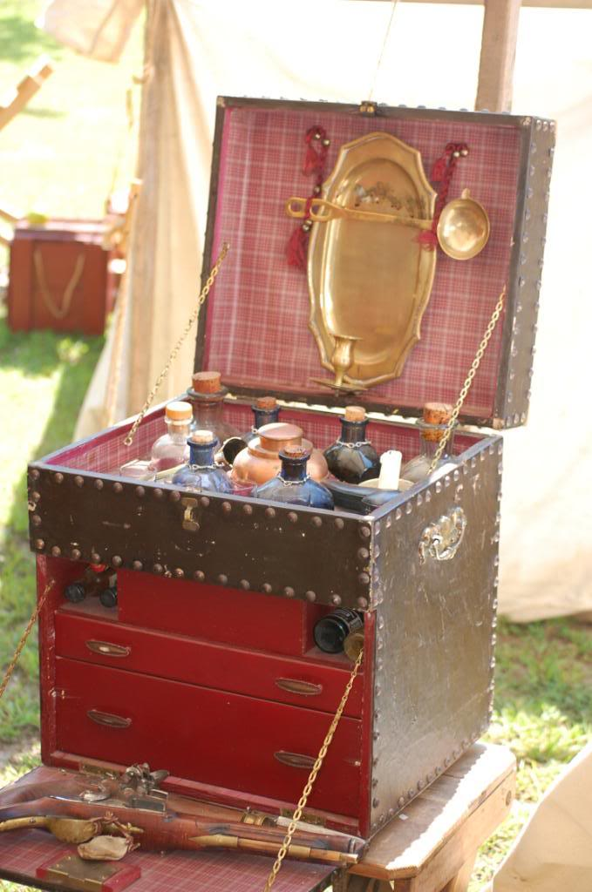
Edited October 19, 2009 by Mission

Raphael Misson
- Member
- title.
Posted August 16, 2009 · Report post
I found another apothecary chest on eBay. The price is ridiculous and it is way out of period (the seller estimates it to be 1870), but it's still kind of interesting for various reasons. (Among them to me are the locking drawer, the bottle shapes, the compartment for the balance scale and weights and the apparent inclusion of the original medicines. I wonder if the tin containers would have been used during period for caustic medicines?) Again, the shape is similar to the drawing by Clowes, although it looks far to small to be an effective ship's surgeon's chest. I believe this would be a personal (home) land-based kit. Home apothecary kits were popular during the 19th century from my reading. According to the label on it it was sold in Portsmouth, so it might have been purchased by a sailor (Who knows?).
The auction's description says,
"YOU ARE BIDDING ON AN EXCELLENT VICTORIAN (C.1870 ) APOTHECARY CABINET IN WALNUT WOOD COMPLETE WITH BOTTLES, PESTLE AND MORTAR, SCALES, AND WEIGHTS, GRADUATED MEASURE, METAL POISON CONTAINERS AND LOCKING DRAWER.THE WALLNUT CABINET IS 101/2" x 7 1/2" x 9" IS IN VERY GOOD CONDITION. THE MEDICINE BOTTLES HAVE THE ORIGINAL LABELS, ONE IS BROKEN."
I saved the photos for later reference. Here are a few of them:

Mission
- Admin
Posted October 31, 2009 · Report post
Aha, another proclaimed sea surgeon's chest has shown up on eBay here. (It's due to end soon, so you'll probably miss it, but I captured some photos so I can blather on about them.) It looks like this:
The description yells at you:
"RARE 19TH PRIMTIVE DOVETAILED MEDICAL SEA TRAVELING CHEST AND BOTTLES. NICE HAND DOVETAILED EARLY MEDICAL CHEST . COMES WITH 21 BOTTLES AND GLASS COVERS. ALSO A FEW EXTRA COVERS. SOME ARE IN GOOD SHAPE AND SOME HAVE CHIPS AROUND THE EDGES, SO IM SELLING THEM ALL SOLD AS IS, AS SEEN CONDITION IN THE PHOTOS. THE HAND DOVETAILED CHEST MEASURES 14 INCHES WIDE BY 10 1/2 DEEP BY 8 INCHES TALL. THE BOX APPEARS TO BE MADE OF PINE. ALL HAND MADE. GREAT FINE QUALITY DOVETAILED CONSTRUCTION. FRESH ESTATE FIND. THE PAST OWNER WAS USEING THIS FOR A SPICE CHEST, SINCE THEY HAVE SOME SPICE LABLES ON SOME OF THE BOTTLES."
The past owner may or may not have been using this as a spice chest as spices were often used as medicines, but that's quibbling. The thing is well outside period and the bottles are round, so I would pass on this anyhow. But the size and shape interest me as it sort of reminds me of a slightly smaller version of the one Clowes talked about in the 15th c. (Note that the design is entirely different and it has no drawers or other compartments like his does.) It doesn't jibe with Woodall's massive list of ingredients in any way, however.
Here's some more photos. It looks like a nice box, if nothing else.

Mission
- Admin
Posted December 24, 2009 · Report post
John over at Machinestchest.com sent me a heads up on a 17th medicine chest that I hadn't seen on eBay. You can find the auction here. It is going for the princely sum of $20,000 which is a bit outside of my price range for re-enactment items. In fact, it is a bit outside of my price range for most things, other than automobiles. It also includes many surgical instruments many of which I know are typical to period (some of them I'm not so sure - like the metal medical containers.)
Note that I do not think this is a sea chest because the design is different than all the sea chests I have seen thus far. It also would appear to be too small for a ocean going surgeon, because such surgeons had to carry all the medicines they would need for the voyage to their destination. This isn't to say it couldn't be carried to sea for more local use, but I suspect it is for a land-based surgeon. Still, it is a lovely piece and so I am sharing it. Thanks to John for the heads up.
The auction says:
"Offered to you is this Extremely Rare 18th century (1700s) antique medical doctor’s mahogany chest with various instruments and equipment inside. This chest was used between 1700 and 1760. The case is made of mahogany wood, reinforced with bronze and lined with velvet plush. It opens as a convenient chest with drawers. Remnants of labels in Latin on some of the drawers. There is a secret lockable drawer on the back, which was used to store some tools made of gold as well as special medicines. The handle is made of bronze and has a special bed designed for it so it doesn’t protrude.
Such chests were used by naval and military doctors and contained everything needed to perform basic surgical and other manipulations whenever a hospital wasn’t available. There are various instruments used in giving lifesaving first aid to soldiers suffering bullet or sharp object wounds, as well as original equipment used in the making of various medicines. There is an amputation saw, surgical needles, scalpel, scissors and bullet probes made of natural bone, as well as metal bullet extractor (scoop). Various other apothecary equipment as scales, bottles, jars etc. Dimensions: 11” x 10” x 7”. Truly a collector’s piece that would proudly take its place in any museum or private collection."
There are a ton more pics on the auction which I won't reprint here for bandwidth reasons, but of all the instruments, I really like the scissors:

sebastian
- Member
Posted December 24, 2009 · Report post
On 12/24/2009 at 2:04 PM, Mission said:
John over at Machinestchest.com sent me a heads up on a 17th medicine chest that I hadn't seen on eBay. You can find the auction here. It is going for the princely sum of $20,000 which is a bit outside of my price range for re-enactment items. In fact, it is a bit outside of my price range for most things, other than automobiles. It also includes many surgical instruments many of which I know are typical to period (some of them I'm not so sure - like the metal medical containers.)
Note that I do not think this is a sea chest because the design is different than all the sea chests I have seen thus far. It also would appear to be too small for a ocean going surgeon, because such surgeons had to carry all the medicines they would need for the voyage to their destination. This isn't to say it couldn't be carried to sea for more local use, but I suspect it is for a land-based surgeon. Still, it is a lovely piece and so I am sharing it. Thanks to John for the heads up.
The auction says:
"Offered to you is this Extremely Rare 18th century (1700s) antique medical doctor's mahogany chest with various instruments and equipment inside. This chest was used between 1700 and 1760. The case is made of mahogany wood, reinforced with bronze and lined with velvet plush. It opens as a convenient chest with drawers. Remnants of labels in Latin on some of the drawers. There is a secret lockable drawer on the back, which was used to store some tools made of gold as well as special medicines. The handle is made of bronze and has a special bed designed for it so it doesn't protrude.
Such chests were used by naval and military doctors and contained everything needed to perform basic surgical and other manipulations whenever a hospital wasn't available. There are various instruments used in giving lifesaving first aid to soldiers suffering bullet or sharp object wounds, as well as original equipment used in the making of various medicines. There is an amputation saw, surgical needles, scalpel, scissors and bullet probes made of natural bone, as well as metal bullet extractor (scoop). Various other apothecary equipment as scales, bottles, jars etc. Dimensions: 11" x 10" x 7". Truly a collector's piece that would proudly take its place in any museum or private collection."
There are a ton more pics on the auction which I won't reprint here for bandwidth reasons, but of all the instruments, I really like the scissors:

PoD
- Member
Posted December 26, 2009 · Report post
I've seen a few examples of that kind of chest and in all the ones i have seen the open shelves are supposed to hold large square bottles (http://www.phisick.com/a6acy1.htm although this is out of period). This would mean that this particular chest could hold 22 bottles of various medicines. The square chests at the top of this post hold 36 by the looks of it (and thats just in the top part).
Would the size of the chest not depend on the size of the ship it was on and the number of crew on the ship, much like modern first aid kits? or would they have been a standard "one size fits all" item?
I found a picture of this Georgian apothecary chest that has a door on both the front and rear of the box which may point to the fact that the square panel on the side of the box in the illustration at the top of the post may indeed be a door. With a box that large it would surely maximize the space available if you were able to get access to the middle of the box too.
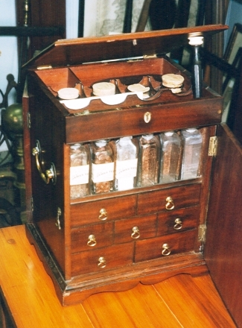

Mission
- Admin
Posted December 26, 2009 · Report post
Square bottles are definitely correct to period. Somewhere around here (probably in this post under one of my other IDs) I quote Moyle on this point. For a chest this old, I wouldn't be surprised if the bottles were changed. I don't think the mortar and pestle would be in the chest at all and I have doubts that the small bone saw would be in there either. Still, they are nice instruments and do appear reasonably close to period as I noted.
I do recall reading something about different sized naval ships requiring more medicines. This could mean bigger medicine chests, especially since everything was hand-built in those days. Of course, they could also have more than one chest if they were standard. (They may have been standardized for ship sizes in the Navy, although I don't really know that.)
On the other hand, Woodall explicitly defines what would go into a medicine chest for the East India company and I would be inclined to think his chests would all be of a similar size. Since Woodall lists over 200 medicines I would be inclined to think a chest like this would be far too small. OTOH, he also suggests that some medicines were highly recommended for certain types of voyages. This implies that not all medicines were recommended for all voyages and we're back to each chest being hand made and assembled.
Still, every sea medicine chest I've seen on either side of period is different than this one, so I still say it is probably a land chest.

Mary Diamond
- Moderator
Posted December 26, 2009 · Report post
Oooh! That is a lovely find, Mission! The scissors are really quite nice ~

Capt. Bo of the WTF co.
- Member
Posted December 26, 2009 · Report post
Oh Crap! Hand-forged scissors.... why, why, why? I don't have enough time as it is you, you, instigator of awfullness. Gotta get through with the worms and linstocks, and now this! You're a bad influence Mission. Bad, bad Mission.
Bo

Mission
- Admin
Posted December 27, 2009 · Report post
On 12/26/2009 at 8:33 PM, Capt. Bo of the WTF co. said:
Oh Crap! Hand-forged scissors.... why, why, why? I don't have enough time as it is you, you, instigator of awfullness. Gotta get through with the worms and linstocks, and now this! You're a bad influence Mission. Bad, bad Mission.
Bo
¿Qué?

PoD
- Member
Posted January 4, 2010 (edited) · Report post
I just found this picture of a russian medical chest from the late 17th century. It's probably not that relevant to pirates and ships but it does show how the bottles were sealed.
Medicine Chest
Russia, Late 17th century
Bone, wood, brass and foil; carved and engraved. 23.5x24.5x23.5 cm
Source of Entry: State Museum of Ethnography of the Peoples of the USSR, Leningrad. 1941
Edited January 4, 2010 by PoD

Mission
- Admin
Posted January 4, 2010 · Report post
There was a thriving industry in home medicine kits in England during period. that definitely looks like a home kit. Bottles would most definitely have been corked like that.

Mission
- Admin
Posted January 6, 2010 · Report post
Oho! A list of ingredients for a Privateering medicine chest from project Gutenburg! Slightly out of period [1742], but the ingredients all look familiar, so it's something. (Thanks to Captain Bo for bringing this link up.)
http://www.gutenberg.org/files/24882/24882-h/24882-h.htm#DOC_158
I come up with 117 ingredients, although it was just a quick count. That again suggests a much bigger box than many shown in this topic. The destination would guide the list of ingredients which the surgeons felt they needed.
Note that I removed a bunch of the instruments to come up with an ingredient count, although the instruments are interesting in a way as well. To wit:
a Pewter Glyst. Syringe [boy, the loved their Clysters...being Pewter, they were soft and thus probably easily damaged...particularly the threads.]
...
Sponge 2 oz.
...
6 Square Bottles [Note that he specifies the shape.]
4 qt. Bott. [Note that he DOESN'T specify the shape.]
4 Blue and white pots
Tow [Linen - makes good sense.]
Vials and pots, 1 Doz.
6 Doz. Corks large and small [We were just talking about corking bottles. Here's more proof.]
a Box
a Broken Red and Do. White Skin [Not sure?]
a Mortar and Pestle
an Iron Laddie [Probably 'ladle']
a Stone Coffee Pot [a interesting one for you non-surgeons, perhaps]

PoD
- Member
Posted March 1, 2010 · Report post
This page has a few items that may well look good in a medicine chest. I particularly like the early 18th century bullet extractor and the personal dental kit.
http://www.etesseract.com/Medical/Medical.html

Mission
- Admin
Posted March 1, 2010 · Report post
That's neat - I didn't know Garangeot started with a three pronged version of his bullet extractor. I would think it would be devilishly difficult to use, though, what with the bullet being covered with blood and fluids and so forth. In fact, I'd imagine that's why he changed it to a screw instead as the article there suggests. (You can see a repro copy of the screw version which is available for a much more reasonable price over at Godwin's site here.)
What I really like on that page is the early personal dental kit:
I haven't seen much reference to them (especially from the 17th c. as the page suggests.) It's curious that the tools have no handles - they're just raw steel. That is not at all like most medical instruments from period which had wood, bone, ivory or other material handles. Of course, they are doubled ended, so that might be why, although it still raises a potential flag in my mind as to their dating.
In any case, a personal dental kit probably wouldn't have been in the kit of a common sailor. These would more likely be used by the gentlefolk from what I've read. Then again, if it is period, since they are raw steel this might suggest they were oriented to the common man. The bone case could hint that they would be used for traveling - or at least be carried about for some reason. Like I said, I really like it.

PoD
- Member
Posted March 1, 2010 · Report post
when I was looking at the picture I assumed they were a lot bigger than they actually are. They are only the length of a tooth pic. I was considering making some but I dont think I can work that small.

Mission
- Admin
- .
Posted March 1, 2010 · Report post
Try a blacksmith. There's usually one or two at the period trade fairs which seem to go on in the winter.
Actually, I didn't look at the size - they're smaller than I thought, too. (Bigger than a toothpick, but not by much.)

PoD
- Member
Posted March 1, 2010 · Report post
On 3/1/2010 at 11:20 AM, Mission said:
Try a blacksmith. There's usually one or two at the period trade fairs which seem to go on in the winter.
Actually, I didn't look at the size - they're smaller than I thought, too. (Bigger than a toothpick, but not by much.)
Actually I was just thinking I bet you could make a set out of some wood nails with a dremel and a blow torch. I shall investigate it when I go to my dads workshop.

Mission
- Admin
Posted April 10, 2010 · Report post
On 7/8/2009 at 9:25 AM, Raphael Misson said:
So, according to Moyle, who is right in the middle of period, unlike any previous author I have cited, we have four instrument and drug transports. The Surgeon's chest, the Drug Chest, the Plaster Box and the Pocket Kit.
I found some further confirmation of this.
“In 1629 King Charles I ordered “all the English ships calling at English ports to have a surgeon on board. The king ordered the Barber-Surgeons’ Company to get 97 trained Surgeons to fill the ships which had not surgeons, for when the law came into force”. A trained Surgeon is a Surgeon plus kit. The Company could not get the numbers. The Apothecaries made up the numbers kitted out all 97 of the Surgeons and Apothecaries with 3 chests: a small wounds chest (first aid or plaster box); a large Surgeon’s chest and an Apothecary chest. The Surgeons were given a crash course in apothecary work, and the Apothecaries one in surgery. The cost of the chests alone would have been very high. Once on board the ship, if the first aid chest was not adequate, the Surgeon/Apothecary would go for the chest he had more knowledge of." (Rory W. McCreadie, The Barber Surgeon's Mate of the 16th and 17th Century, p. 23)
I wonder what McCready's source is?

PoD
- Member
Posted October 1, 2010 · Report post
I finally found the picture from "A Prooved Practice" again. Thought i'd post it as the links to the original picture disappeared.
Theres a nice page in his book too of a man who looks like he's fallen into the weapons storage chest

Mission
- Admin
Posted October 2, 2010 · Report post
On 10/1/2010 at 6:28 PM, PoD said:
I finally found the picture from "A Prooved Practice" again. Thought i'd post it as the links to the original picture disappeared.
Thanks! I hadn't noticed it was no longer appearing in the first post. Maybe I should fix that...
On 10/1/2010 at 6:28 PM, PoD said:
Theres a nice page in his book too of a man who looks like he's fallen into the weapons storage chest
I can't immediately bring to mind whose surgical manual that appears in, but it's actually a sort of diagram to show the different kinds of wounds a person can receive and which the surgeon may have to deal with. (It seemed a bit useless to me as a teaching aid when I first saw it, but it IS quite dramatic looking.)

PoD
- Member
Posted October 3, 2010 (edited) · Report post
These Broadsides from c.1688 - 1710 have pictures of a rectangular medicine chest in it
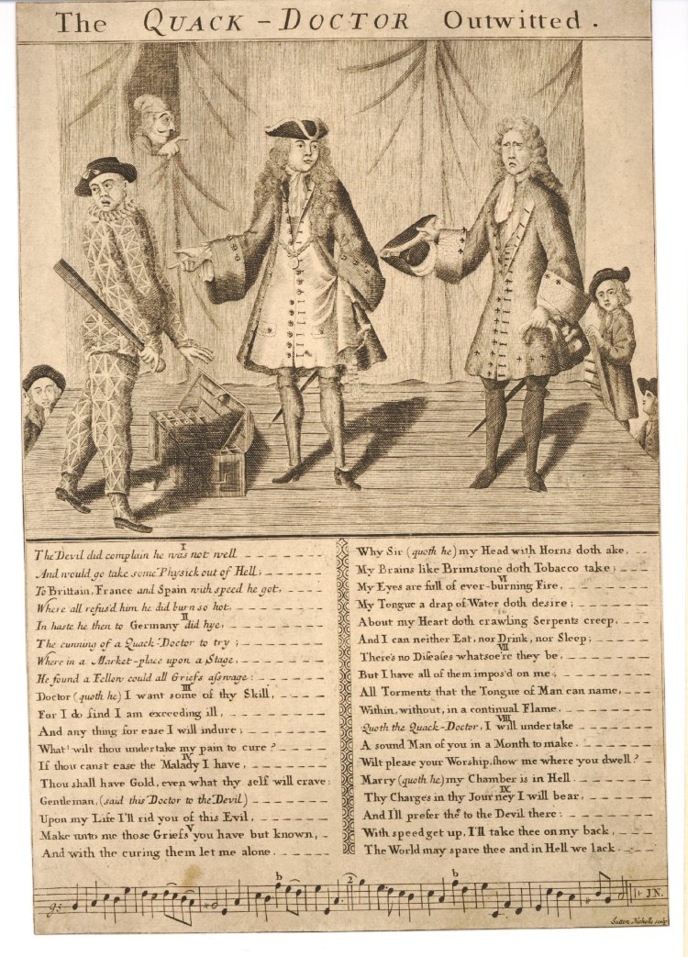
http://www.britishmu...asset_id=333782
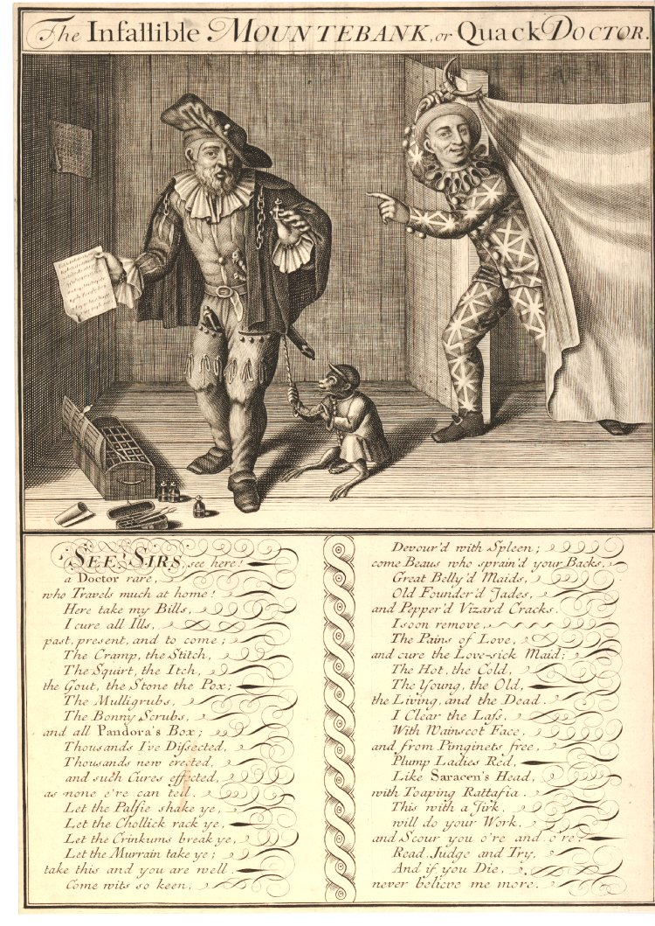
http://www.britishmu...asset_id=333656
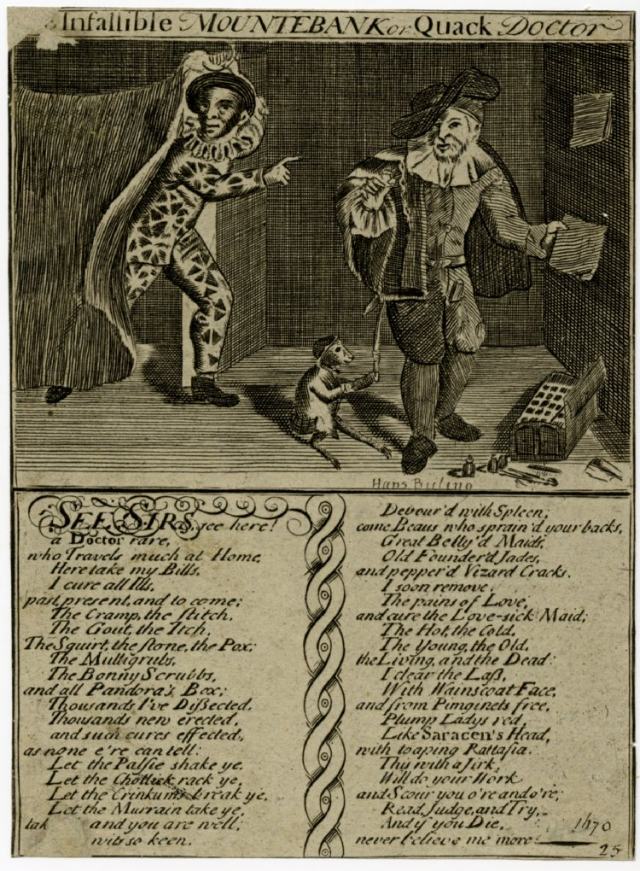
http://www.britishmuseum.org/research/search_the_collection_database/search_object_image.aspx?objectId=3068536&partId=1&searchText=quack&fromDate=1650&fromADBC=ad&toDate=1730&toADBC=ad&orig=%2fresearch%2fsearch_the_collection_database.aspx&numPages=10&currentPage=3&asset_id=353218
Edited October 3, 2010 by PoD

Mission
- Admin
Posted October 3, 2010 · Report post
Wow! Nice find, PoD! I love the detail of the top of the chest. These are much more like what I would expect a sea chest to be like than some of the other examples I have cited with the center opening doors. I notice the bottles appear to be square-bottomed as well. Very nice find!
Interesting too that they have curved tops. What do you make of that, Ed?

PoD
- Member
Posted October 3, 2010 · Report post
On 10/3/2010 at 9:52 AM, Mission said:
Wow! Nice find, PoD! I love the detail of the top of the chest. These are much more like what I would expect a sea chest to be like than some of the other examples I have cited with the center opening doors. I notice the bottles appear to be square-bottomed as well. Very nice find!
Interesting too that they have curved tops. What do you make of that, Ed?
I was looking at the size of the bottles and I got to wondering if they might actually be double layered boxes (much like how modern tool boxes have the tray bit that lifts out to get to space below). From the top one it looks like there is 6 rows of 5 sections for the bottles making 30 bottles. If it was double layered that would increase to 60 bottles.
Interestingly the little case on the floor next to it reminds me a lot of this one on an ebay auction:
http://cgi.ebay.co.uk/Late-17th-Century-English-Shagreen-Instrument-Case-/310256693955?pt=UK_Antiques_Science_RL&hash=item483cbd72c3

Mission
- Admin
Posted October 3, 2010 · Report post
It probably had drawers in the bottom part. If you re-read some of the older posts, you'll see that this was typical of medicine chests.

PoD
- Member
Posted October 3, 2010 · Report post
ok course. i forgot about that. It's a pity the top one isnt clearer as you can just make out the front but not in any detail

PoD
- Member
Posted October 6, 2010 · Report post
Here is another picture showing a clearer image of the chest.
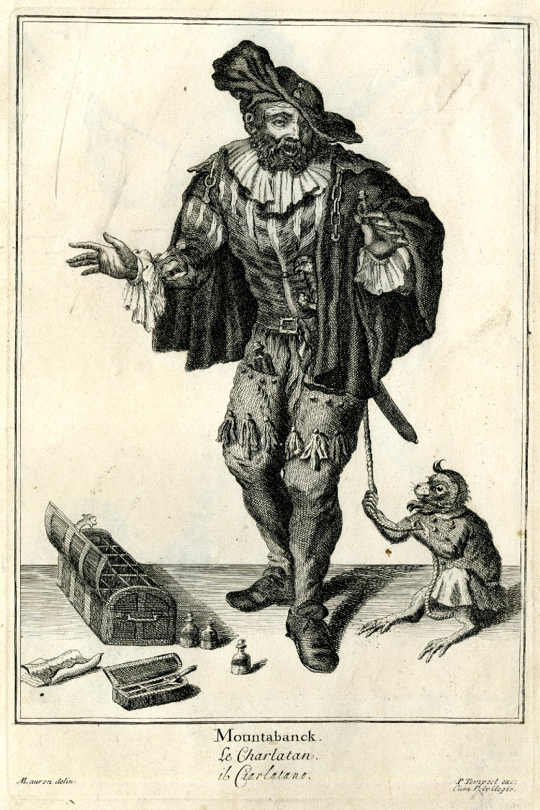
From this picture it looks like the chest has 3 rows of 6 spaces which are the same size then a row nearest the front of the chest that is thinner than the rest. I wonder if this was how they were or if the artist just didnt space out the dividers properly in the drawing. I like the fact it shows the bottles as having spherical stoppers in them too

PoD
- Member
Posted October 6, 2010 (edited) · Report post
the small box may well be like the one I mentioned above as I have just found another one here:
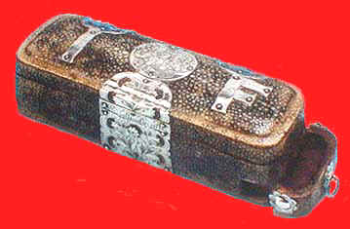
Obviously i doubt that the general medical population had one this ornate though although the basic design may have been the same. The little drawer underneath would account for where the spatulas go seen in the broadsheet pictures
http://www.antiquescientifica.com/articles%203.htm
ooooooooh look what I just found too:
Surgical instrument case and instruments, English, 1650-1700.
The case is made of silver mounted shagreen (fish skin), bearing the arms of the Barber Surgeons' Company. The instruments consist of scisors, a tongue depresor, forceps, probes, and lancets. The double-edged blades of the lancets are placed between tortoise-shell covers with inverted screws, they were used for opening veins for blood letting. The various sizes and shapes of lancet were used on veins of different sizes or locations.
.....oops got a bit excited there.
Edited October 6, 2010 by PoD

Mission
- Admin
Posted October 6, 2010 · Report post
Nice detail on the scissors and forceps. I would love to get some more period-style scissors and forceps in my set - a good kit would have had a wide variety of them. ("Oh mighty eBay...give me cool antique scissors and forceps to bid upon.")
Those you have shown are probably all pocket kits. Somewhere previously in this thread I explained that the average sea surgeon would have had (at least) four medical containers: the large medicine chest, the plaster box, an instrument box and a pocket kit. There are also some references to barbering kits in some manuscripts.
I think it is Yonge who refers to a pocket kit or some other one of his smaller boxes being wrapped in crocodile or snake skin. He received it by mistake after his ship was taken at sea and his medical items were being returned to him by his captors. So it's not out of the question that a sea surgeon might have had some nicer boxes...although generally I would think it would be less rather than more likely. Many sea surgeons seem to have gone to sea because they didn't have the money or social connections to get a more lucrative land-based position.

PoD
- Member
Posted October 6, 2010 · Report post
On 10/6/2010 at 8:15 AM, Mission said:
Nice detail on the scissors and forceps. I would love to get some more period-style scissors and forceps in my set - a good kit would have had a wide variety of them. ("Oh mighty eBay...give me cool antique scissors and forceps to bid upon.")
Those you have shown are probably all pocket kits. Somewhere previously in this thread I explained that the average sea surgeon would have had (at least) four medical containers: the large medicine chest, the plaster box, an instrument box and a pocket kit. There are also some references to barbering kits in some manuscripts.
I think it is Yonge who refers to a pocket kit or some other one of his smaller boxes being wrapped in crocodile or snake skin. He received it by mistake after his ship was taken at sea and his medical items were being returned to him by his captors. So it's not out of the question that a sea surgeon might have had some nicer boxes...although generally I would think it would be less rather than more likely. Many sea surgeons seem to have gone to sea because they didn't have the money or social connections to get a more lucrative land-based position.
Yep I love the instruments. I like the box thats on ebay at the moment but I cant afford to pay out that much for it.

PoD
- Member
Posted October 6, 2010 · Report post
Do you have any physical descriptions for the plaster box rather than its contents?

Mission
- Admin
Posted October 6, 2010 · Report post
I doubt that instrument case will sell. He wants too much for it.

Mission
- Admin
Posted October 6, 2010 · Report post
On 10/6/2010 at 8:44 AM, PoD said:
Do you have any physical descriptions for the plaster box rather than its contents?
No, I have no idea what it looked like - everything I've found I've re-printed here. I'm going to guess that it had at least one tray in it like some of the instrument boxes I've seen from time to time.

PoD
- Member
Posted October 6, 2010 · Report post
I found this on the British History Online site:
Plaster box
[playster boxe; playster box; playstar box; plaister box]
Not, as might be thought, simply a BOX containing PLASTER or plasters, but a complete kit for a surgeon. Randle Holme's illustration is not overly helpful, but his description compensates by its fullness. The surgeon's plaster box, he wrote, consisted of three parts; first of all the box itself, 'in which lyeth such Instruments as serve for present use, which are small ones only'. These included Spatulas, FLEAM, Directorie, Probe, Stitching NEEDLE and QUILL, LANCET, BORAX (or Burras) PIPE, Levitor and Uvula SPOON. The second component was the lid with a pouch in which to keep LINT, and the third the 'Drawer, at the bottom of the Box, in which are kept all the Plasters ready made, and are for any sudden occasion'. These 'Emplasters which this lower Box or Drawer doth contain, are at the least three or more several kinds, as Emplastrum Stipticum Paracelsi' (presumably EMPLASTRUM PARACELSI), Emplastrum Diachalcichos (presumably DIACALCITHEOS), Emplastrum de Lapide Calaminari, and EMPLASTRUM E MINIO (Emplastrum de Minio) [Holme (2000)]. Entries like '1 plaisterbox w'th som smal Instrum's therein' [inventories (1685)] fit Holme's description well. Some surgeons did have more complex equipment, for example, in the will of one, he left 'to my said Brother Richard Mayott my Plaster Box with the Instruments therein And my Salvatory and my Case of Lancetts with the Instruments therein' [inventories (1686)]. The term seems to have died out, and has not been noted after 1701 [inventories (1701)].
I am just trying to find this illustration that was by Randle Holme in his book The Academy of Armory written in 1701 but I am not having much joy. Reading that description though it almost sounds as if the small box in the post above is the actual plaster box rather than the pocket kit like we originally thought. If thats the case then I am wondering what the emplasters actually look like as I'd imagined them to be large bulky bandages. If this box is a plaster box then they mustn't be must larger than a modern day band aid

Mission
- Admin

Posted October 6, 2010 · Report post
Excellent find! Thank you ever so much for digging that up! In fact, in design, it sounds very much like the instruments box (which is not the same as that little thing they're calling an instrument box - the ones I'm thinking of held the bone saws, so they would be 2 or 3 feet long and nearly a foot wide.)
I had downloaded the Holme book from the university library, but now I find that I only got the first page. (This has happened to me a couple of times; I need to watch that fool download mechanism on their computers more closely in the future...) I perused the Armory very quickly when I found it on the Uni-computer, and it's seemed to me like an almost random scattering of sketches and descriptions of all manner and sort of things. This book reads like stereo instructions.
I believe Hurricane has it on CD although I doubt he's reading this thread. If you're really interested, you might shoot him a pm and see if he can dig it up for you.
In regard to the box you found on eBay, I would say it's too small to be a plaster box based on my understanding of what it would have contained. The plasters for large wounds of the extremities could be quite large - I seem to recall dimensions of 3 and 4 inches wide that would probably be at least that long if not more. You could hardly fit more than a few band-aids in the drawer of that is about 1/4 - 1/3 the height of a box that is 6.5" x 2.3" x 2" tall. Although I could well be wrong...

PoD
- Member
Posted October 6, 2010 · Report post
yeah i might just do that. I can only find an illustrated audio book of it, however they manage to do that I dont know.
Seems emplasters were basically a paste on silk or similar materials so they would get a few in that little drawer i imagine

Mission
- Admin
Posted October 6, 2010 · Report post
Something I had not thought of before was to look through the images I have scanned from Elizabeth Bennion's excellent book Antique Medical Instruments (Sotheby Parke Bernet, University of California Press, 1979) and John Kirkup's similarly wonderful The Evolution of Surgical Instruments; An Illustrated History from Ancient Time to the Twentieth Century (historyofscience.com, Novato, CA, 2006).
I found a photo of the instruments from a pocket kit as well as one with the box included for you that I believe agree with your images:
Figure 84, Pocketcase Instruments, Savigny, 1798 (Kirkup, p. 68)
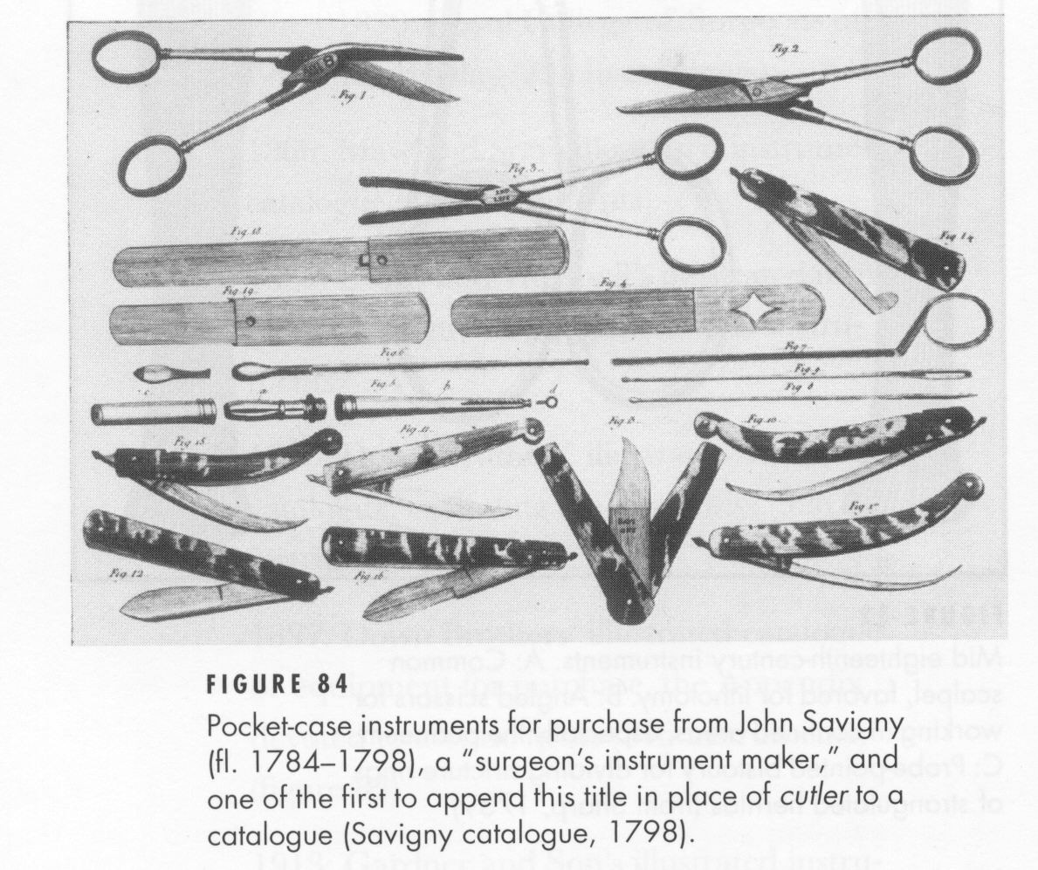
Ch. 3 Figure 15., Contents of a pocket case of instruments, dated 1731. (Royal College of Surgeons of England) (Bennion, p. 64)
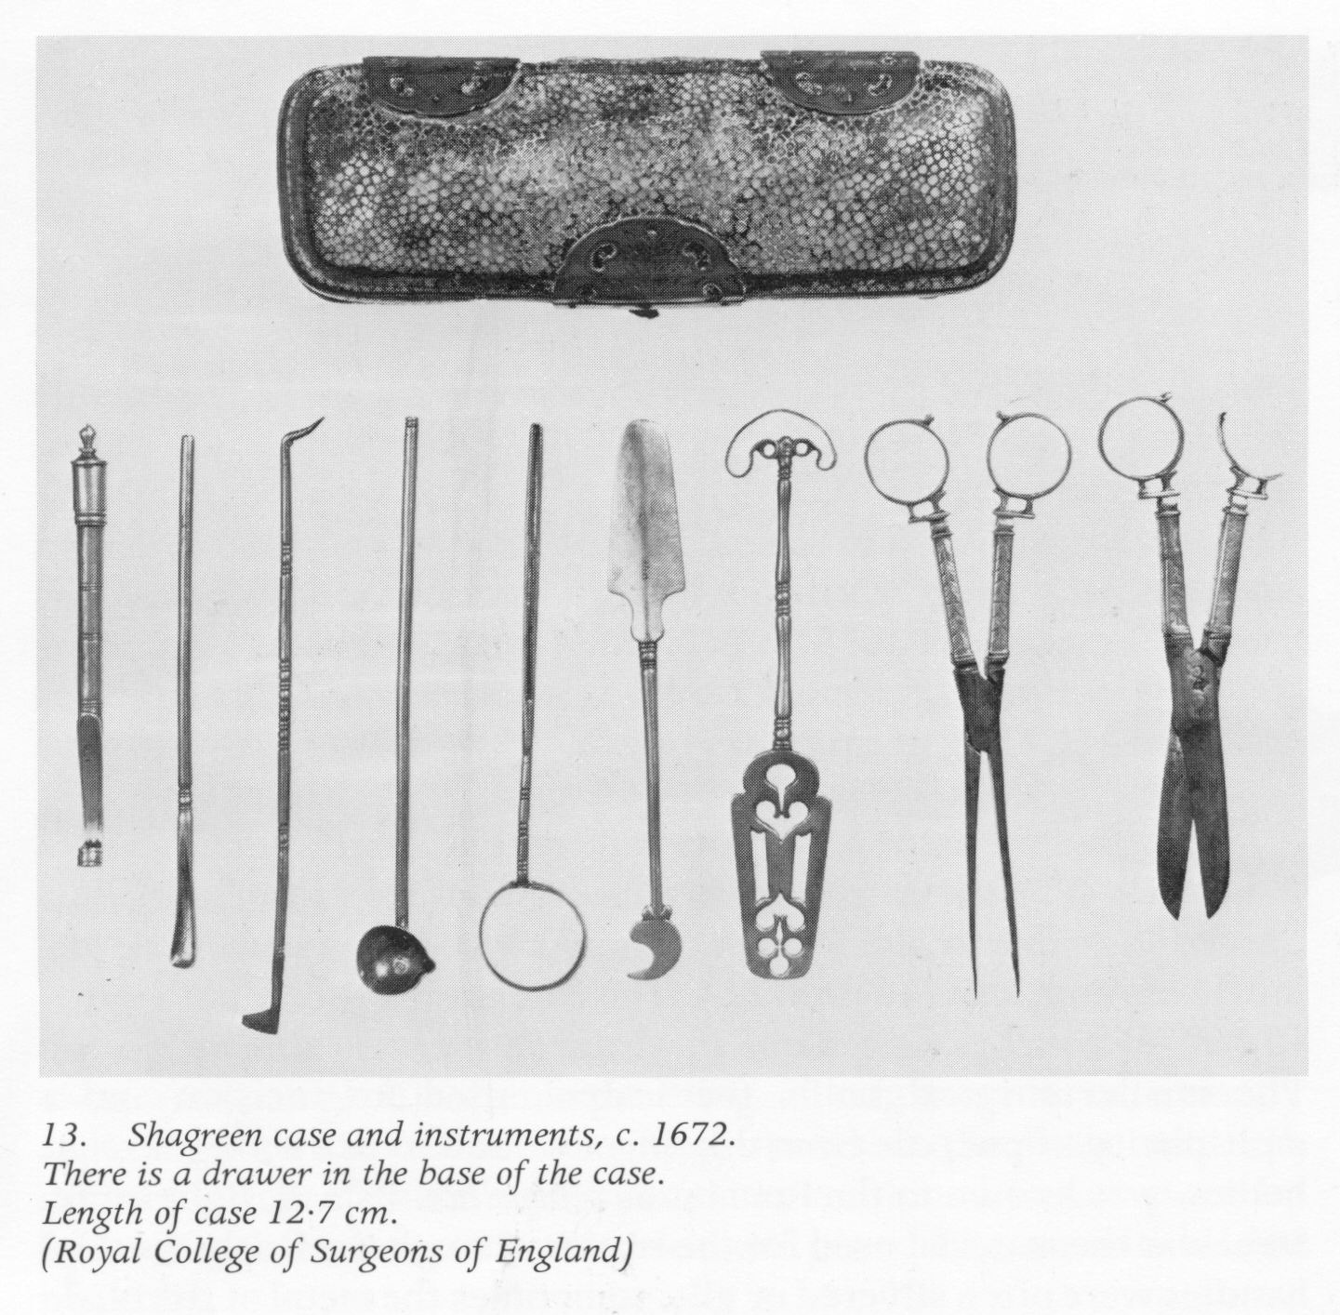
"The seventeenth-century Prujean Collection, now in the Museum of London, includes a case with two trays of intricately-shaped compartments lined with marbled paper (pls. 4-5). Pocket cases opening flat in two halves were made in wood at the same period.
__
There is a brass instrument case in the Victoria and Albert Museum, though shagreen seems to have been the most favoured material for these small cases throughout the seventeenth centuries, the boxes being about 12 to 15 cm long with rounded ends. Another particularly interesting example, apparently from 1672, is that shown with the instruments in pl. 13 ([Ch 3.] p. 62). This has a drawer in the base, presumably to hold the sharper instruments more safely. A similar one is in the possession of the Wellcome Collection…From the mid-eighteenth
__
century and for most of the nineteenth century, instrument cases of leather, sharkskin, and brass-bound mahogany were standard, fitted inside with velvet-covered slots, larger ones having several trays and side-carrying handles…
Silver cases of the etui-type for lancets and, occasionally, other instruments, date from the early eighteenth century. They are of tapering design with the lid at the thicker end, often with intricate hinges and spring clasp; the interiors fitted with a slotted silver grille to hold the lancets… by 1780-90 they had become more delicate and attracted, very often, the prettiest and most intricate bright-cut designs.” (Bennion, p. 276-8)

Mission
- Admin
Posted October 6, 2010 · Report post
Emplasters were gummy medicines that were smoothed on to bandages. Kind of like pre-medicated bandages.
“…you are to get [your chests], with your self and Crew, on Board; and see them placed in a dry Place, and as convenient to be come at as possible. And let your Surgery Chest be fast lashed that it may not over set in bad Weather by the rowling of the Ship.
__
And being on Board, see that your dressing box is furnished. [Note: This is the plaster box.]
That is a box with 6 or 8 Partitions in it, and a Place for Plaisters ready spread. In the Partitions you put your Pots and Glasses of Balsams and Oyles for present use.
Now this Box as well as your pocket Instruments must be carried every Morning to the Mast between Decks, where our Mortar is usually rung, that such as have any Sore or Ailment may hear in any part of the Ship, and come thither to be drest. [Note: This indicates that there was a pocket kit of some kind as well as a plasters box.] But such as by reason of illness cannot come thither you must go to them where Lye.” (Moyle, p. 45-6)

PoD
- Member
Posted October 6, 2010 · Report post
On 10/6/2010 at 4:02 PM, Mission said:
Emplasters were gummy medicines that were smoothed on to bandages. Kind of like pre-medicated bandages.
"…you are to get [your chests], with your self and Crew, on Board; and see them placed in a dry Place, and as convenient to be come at as possible. And let your Surgery Chest be fast lashed that it may not over set in bad Weather by the rowling of the Ship.
__
And being on Board, see that your dressing box is furnished. [Note: This is the plaster box.]
That is a box with 6 or 8 Partitions in it, and a Place for Plaisters ready spread. In the Partitions you put your Pots and Glasses of Balsams and Oyles for present use.
Now this Box as well as your pocket Instruments must be carried every Morning to the Mast between Decks, where our Mortar is usually rung, that such as have any Sore or Ailment may hear in any part of the Ship, and come thither to be drest. [Note: This indicates that there was a pocket kit of some kind as well as a plasters box.] But such as by reason of illness cannot come thither you must go to them where Lye." (Moyle, p. 45-6)
Ahhh you know I read that once and completely forgot about the mention of the pots. Ok thats my next job to find a picture of one of them ha ha.
Do you have any measurements for the "Plaisters ready spread" from any of your sources? This should give me an indication of what size box i am looking for.

PoD
- Member
Posted October 6, 2010 (edited) · Report post
ok I have just found this Broadside in the British museum with a picture of a dressing case
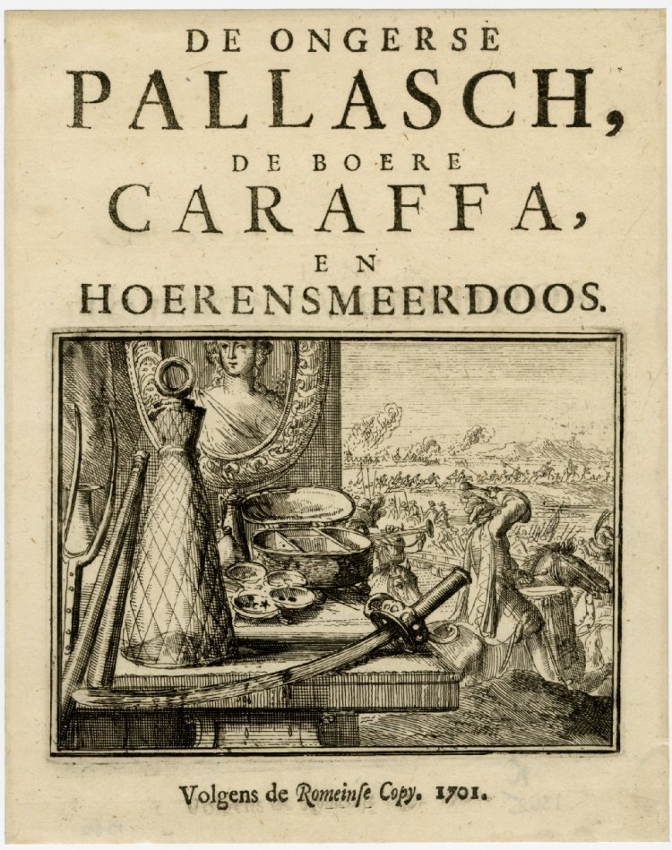
Its the large oval one.
Date
1701
Schools /Styles
Dutch
Description
Title page to a tract entitled "De Ongerse Pallasch, de Boere Caraffa, en Hoerensmeerdoos", no. 18 in the series entitled "Esopus in Europa"; in the centre, an etching showing a table against which rest a pitchfork and flail, and on which is a peasant's flask, a sabre dripping blood, and a toilet set including two perfume bottles, a dressing case and a set of dishes containing face-patches of various shapes; hanging behind is a portrait of a young woman; on the right, a mounted drummer and trumpeter and in beyond cavalry cross a pontoon bridge and gallop towards a burning town. 1701
Looks more like a jewellery box to me though
Edited October 6, 2010 by PoD

Mission
- Admin
Posted October 6, 2010 · Report post
I'm not at my computer, but I'd think the dims on the plaster chest would depend more on the instruments stored in them than the plasters. The widest bandage I've read about it 4". But that wouldn't hold very many instruments. OTOH, Yonge refers to taking his with him when he was captured, so I'm guessing it was small enough to be portable.
Understand too that the sizes of these things would probably have varied. Woodall's medicine chest calls out a great many more medicines than most others who had listed the ingredients required in a medicine chest. This implies that his surgeons required a larger chest. Since everything was hand-built at this time, I would also expect that chest and cabinet sizes would vary from production lot to production lot, from manufacturer to manufacturer and material would vary based on what was easiest, cheapest and/or most readily available that would fit the need.
What are you doing? Making a full medical kit? Do you have your instruments? I am planning to design my kit around my instruments if I ever get to it...my Bone Saw is 25" long and the instrument case has to be able to accommodate it at the very least.

PoD
- Member
Posted October 7, 2010 · Report post
On 10/6/2010 at 9:30 PM, Mission said:
I'm not at my computer, but I'd think the dims on the plaster chest would depend more on the instruments stored in them than the plasters. The widest bandage I've read about it 4". But that wouldn't hold very many instruments. OTOH, Yonge refers to taking his with him when he was captured, so I'm guessing it was small enough to be portable.
Understand too that the sizes of these things would probably have varied. Woodall's medicine chest calls out a great many more medicines than most others who had listed the ingredients required in a medicine chest. This implies that his surgeons required a larger chest. Since everything was hand-built at this time, I would also expect that chest and cabinet sizes would vary from production lot to production lot, from manufacturer to manufacturer and material would vary based on what was easiest, cheapest and/or most readily available that would fit the need.
What are you doing? Making a full medical kit? Do you have your instruments? I am planning to design my kit around my instruments if I ever get to it...my Bone Saw is 25" long and the instrument case has to be able to accommodate it at the very least.
The group I am part of do the Barber-surgeon display for the public so I am basically looking at improving their kit. I am just making the Apothacary chest shown in the broadsheets and i'd like to do the plaster and surgical cases at some point too. I am not sure what instruments they have yet. I know they have a collection of larger tools such as a Bone saw, amputation knives and a clyster syringe but I dont think they have any of the smaller pocket kit type stuff.
Other than that I just find the medical instruments really interesting and like to research them.

PoD
- Member

Posted October 7, 2010 · Report post
On 10/6/2010 at 4:02 PM, Mission said:
And being on Board, see that your dressing box is furnished. [Note: This is the plaster box.]
I wonder if this is implying that the box is for dressings or if it is a box called a dressing box. From what I can tell a Dressing Box was a box used by travellers to store all their personal grooming items. I wonder if the Dressing Box on a ship was actually one of these but containing basic medical kit rather than grooming items. Theres an example of a later 19th century Dressing box here:
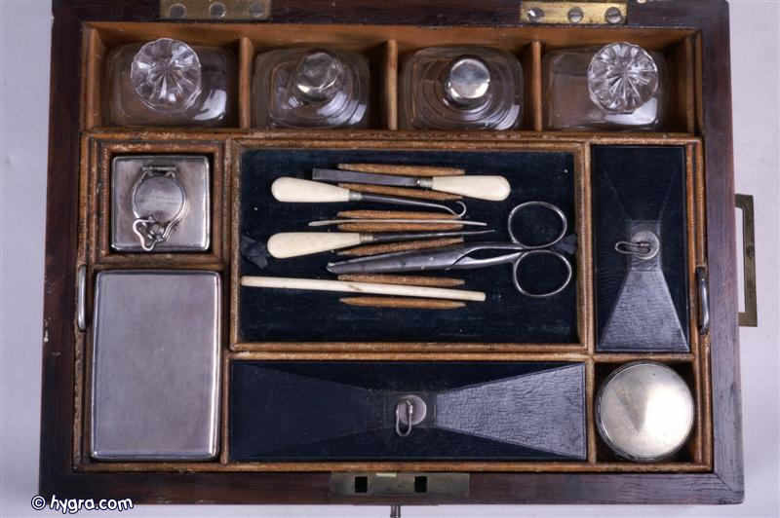
Other than that I got to thinking. The only other type of medical box I am finding other than the large chest and the small instrument pocket case is the small folding door chests. Now these have space for all the stuff mentioned in a plaster box and are easily portable due to the handle on the top. These were definately around on ships in the GAOP in some form or another. Do you think maybe that these could be what they are calling a plaster box or do you thing its something else entirely?

This is what i originally imagined the plaster box to look like. This is a ships one from 1845 though:

Mission
- Admin
Posted October 7, 2010 · Report post
Ah, very cool! I look forward to seeing pics of your group's final results. If researching the instruments really interests you, check out those two books I cited above - you can probably get them through your local library. (They're wayyy too expensive to buy - I looked - hard.) They contain a lot of really good photos and info.
On 10/7/2010 at 6:18 AM, PoD said:
Theres an example of a later 19th century Dressing box here:
Notice how the top appears to drop into the outside box to cover the contents in the bottom of the box. This is what I was talking about before. I wouldn't think a plaster box would have a drawer - it would be more like an instrument box which often has a similar drop-in top section. Thanks so much for posting that - I hadn't seen ANY plaster boxes before this and had been previously speculating it was made of plaster. (!! )
On 10/7/2010 at 6:18 AM, PoD said:
This is what i originally imagined the plaster box to look like. This is a ships one from 1845 though:
Other than that I got to thinking. The only other type of medical box I am finding other than the large chest and the small instrument pocket case is the small folding door chests. Now these have space for all the stuff mentioned in a plaster box and are easily portable due to the handle on the top. These were definately around on ships in the GAOP in some form or another. Do you think maybe that these could be what they are calling a plaster box or do you thing its something else entirely?

Actually, I suspect this style is mostly for land-based medicine chests. If the ship were rocking and rolling on the waves or taking broadsides in a battle, a chest like that would be a huge PITA to work with because the doors would swing unless fastened...and then you wouldn't have easy access to the stuff inside. Several sea surgery books from period go into great detail about preparing the operating area for battle and they don't include fastening up your chest.
My concept (and I haven't completely proven this, so it's partly opinion) is that the plaster box and medicine chests were similarly done with drop in sections like the first photo you have posted. I didn't really have a clear thought on the pocket kit until you started this conversation, so that was actually a big help to me.
The medicine chest would be more like the Clowes chest that you posted a photo of with a top honey-combed section for square-bottomed bottles - some large ones for frequently used medicines and many smaller ones for less frequently used medicines. It would have a lockable lid.
Then there would be two or three drawers that went into the chest below the level of the honeycombs, possibly running the full length of the chest (like the machinist chest in my first post in this thread) to enable the housing of long instruments. (I base this on Woodall's description of some of the stuff that he put into the chests.) One of those 'drawer rows' may have consisted of several smaller drawers like the Clowes chest instead of running the full length. If so, my guess would be the top-most one.
The front would have had some sort of fastening & lockable cover as chests purchased by surgeons for the navy were sealed so that they could not be tampered with. There may also have been a secret drawer in the back for medicines that the sailors would have been likely to steal - I have seen more than one reference to such a thing. If so, the bottom drawer would have been shallower than the other drawers to accommodate the secret drawer.
I should note that my model for a medicine chest is based largely on the Woodall description of the chest and (more specifically) what it contained. No doubt some surgeons had kits like the one you show above simply because that's what they had. Although I think that sort of chest would have been more expensive than the simple one I am describing.
On 10/7/2010 at 6:18 AM, PoD said:
This is what i originally imagined the plaster box to look like. This is a ships one from 1845 though:
I would suggest that is a home-made kit. Home medicine kits were somewhat popular around period. They would have been small, simple and compact like that one. I believe the Bennion book gives a lot more detail on these.
Keep in mind that on long sea trips (many lasting weeks, if not months) the only medicine shipboard would be what the surgeon brought. He could never be sure what he would find in whatever ports the ship stopped, which is why I believe Woodall recommended so many medicines be stocked from the outset. This also informs us as to the necessary size of the chest. One such as you have above would probably have been too small for a long voyage.

PoD
- Member
Posted October 7, 2010 · Report post
I have just come across John Kirkup's The Evolution of Surgical Instruments; An Illustrated History from Ancient Time to the Twentieth Century on google books (or a section of it at any case).
http://books.google.co.uk/books?id=eg_SpXBf4eIC&lpg=PR17&dq=The%20Evolution%20of%20Surgical%20Instruments%3B%20An%20Illustrated%20History%20from%20Ancient%20Time%20to%20the%20Twentieth%20Century%20pdf&pg=PA42#v=onepage&q&f=true
I've also just found this picture of a surgical instruments case from the 18th century:
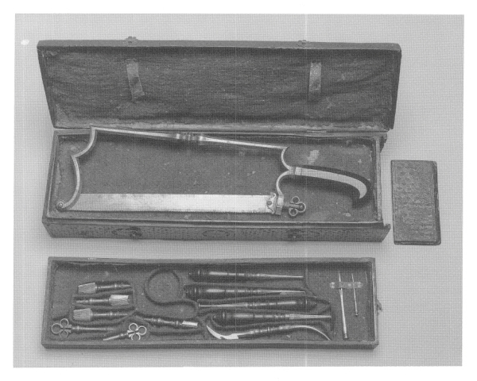

PoD
- Member
Posted October 7, 2010 · Report post
another view of the science museum pocket kit with some of the instruments in it:
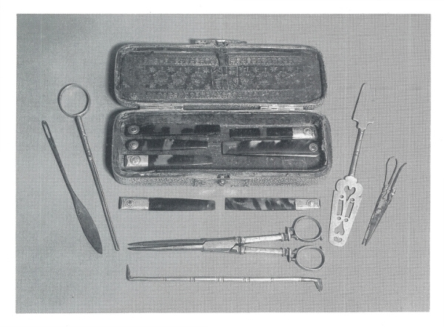

PoD
- Member
Posted October 7, 2010 · Report post
a 1653 Instrument chest:
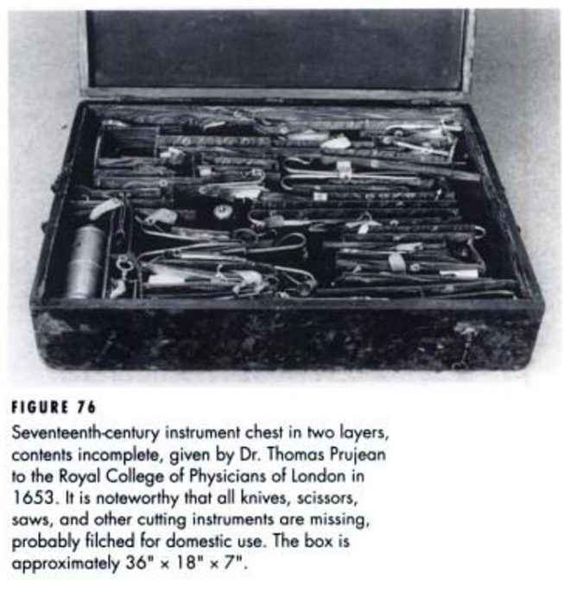
I assume the lower layer held the larger instruments

Will Fiddle
- Member
Posted October 20, 2010 (edited) · Report post
Thanks for the posting of material from Moyle. Much work to be done just on this series of quotes, and a new source to be dug up.
Will
Edited October 20, 2010 by Will Fiddle

Mission
- Admin
Posted October 20, 2010 · Report post
Moyle is probably the resource I'd be most likely to recommend to someone who wanted to read a single GAoP period sea-surgeon book. Yeah, yeah, Woodall wrote the first one and it was for the merchant ship surgeons (who were the most likely to be taken by pirates), but Moyle writes in a way that's easy to read and comprehend as well as being direct and to the point. Plus his book was published during period where Woodall's came out 30-50 years earlier. Woodall's book is also a challenge to read (well, until you get the hang of it...and even then...) and sometimes tends to wander a bit. Still, Woodall contains rich descriptions and lots of info on medicines. (Although, from my experience, the medicines don't generally excite the crowds nearly as much as descriptions of the operations and surgical tools.)
[Edit: While I'm talking books, here is a post where I give my short list of books that I think would be most helpful to period surgeon impressions. It also contains links to most of the topics on sea surgery here on the Pub.]

PoD
- Member
Posted November 27, 2010 · Report post
is there any reference material anywhere was to the contents of the bottles in an Apothecary chest? What medicines and such?

PoD
- Member
Posted January 3, 2011 · Report post
This 1823 book titled "Transactions of the Associated Apothecaries and Surgeon- apothecaries of England and Wales" mentions the contents of a Dressing Box. Not sure if this is what would have been in an early 18th century one but its a good starting point.
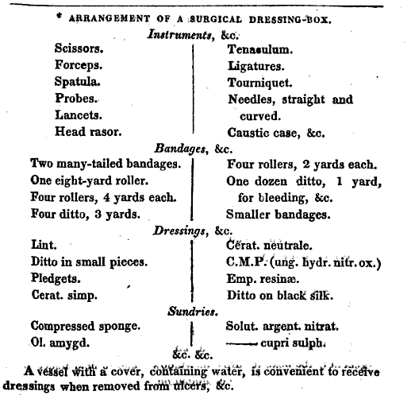

Mission
- Admin
Posted January 5, 2011 · Report post
On 11/27/2010 at 7:18 PM, PoD said:
is there any reference material anywhere was to the contents of the bottles in an Apothecary chest? What medicines and such?
What you really need is a copy of Woodall's book the surgion's mate. There is actually more information in there which answers your question than I care to type in and re-print. We're talking 50+ pages of material including long lists of tools, medicines, their uses and their locations in the chest (sort of) and so forth. It will require some reading and deciphering effort, but it you want a period surgeon's chest, that's the best way I know of to get the info you're asking for.
I urge you to go to the source. I explain how you can get a pdf copy with a little effort in this post. Get the 1639 version of the book as it also has material on barbering and other miscellaneous equipment in the added chapters.
Good luck!

PoD
- Member
Posted January 7, 2011 · Report post
On 1/5/2011 at 9:53 AM, Mission said:
On 11/27/2010 at 7:18 PM, PoD said:
is there any reference material anywhere was to the contents of the bottles in an Apothecary chest? What medicines and such?
What you really need is a copy of Woodall's book the surgion's mate. There is actually more information in there which answers your question than I care to type in and re-print. We're talking 50+ pages of material including long lists of tools, medicines, their uses and their locations in the chest (sort of) and so forth. It will require some reading and deciphering effort, but it you want a period surgeon's chest, that's the best way I know of to get the info you're asking for.
I urge you to go to the source. I explain how you can get a pdf copy with a little effort in this post. Get the 1639 version of the book as it also has material on barbering and other miscellaneous equipment in the added chapters.
Good luck!
Ahhh yeah EEBO is the holy grail. I've been trying to get into that for years now. The university I went to doesnt have access to it. You have to have a university account to access it from the universities that do have it over here and they dont give you one of them unless you are a student there.

Silver
- Member
Posted January 9, 2011 · Report post
there is a very active web site called chirurgeons-the staff of the serpent/medical history. it is a yahoo group, i find them to be very helpful in expanding the knowledge of medical history. i also have been working on a medical addition to my program and have gotten alot of help from them, many of them are on your side of the pond. give them a hail.

PoD
- Member
Posted February 19, 2011 · Report post
Wooden barber surgeon's case, large rectangular box with a hinged lid, contains twenty shaving accessories, French, 1715-1830. Full view, open case with some contents arranged outside.
You'd think they could narrow it down a bit on when it was made. Over a hundred years in that time period. Bit rubbish for a museum not to be able to get it more accurate.

Mission
- Admin
Posted January 14, 2012 · Report post
I am putting together a presentation on pirate surgeons for next month and I stumbled across this bit from Rory McCreadie's pamphlet The Barber Surgeon’s Mate of the 16th and 17th Century. (With a nod of thanks to Ed Fox for getting me a copy of that.) I have emphasized a point regarding the surgeon's chest.
“In 1629 King Charles I ordered "all the English ships calling at English ports to have a surgeon on board. The king ordered the Barber-Surgeon's Company to get 97 trained Surgeons to fill ships which had not surgeons, for when the law came into force”. A trained Surgeon is a Surgeon plus kit. The Company could not get the numbers. The Apothecaries made up the numbers kitted out all 97 of the Surgeons and Apothecaries with 3 chests: a small wounds chest (first aid or plaster box); a large Surgeon’s chest and an Apothecary chest. The Surgeons were given a crash course in apothecary work, and the Apothecaries one in surgery. The cost of the chests alone would have been very high. Once on board the ship, if the first aid chest was not adequate, the Surgeon/Apothecary would go for the chest he had more knowledge of. These young men were probably the first doctors as we know them today, and were called Apothecaries/Surgeons. Before this time only the best surgeons would study both, for their own use. At one time, the Apothecaries and Surgeons planned to buy a shared barge (1664), but the Apothecaries could not raise the money for their share at the time. The Surgeons acquired their own.” (McCreadie, p. 23)
What I find interesting in that is that this decree separates the Surgeon's chest and the Apothecary chest - further, it denotes a LARGE surgeon's chest. This hearkens back to William Clowe's chest (seen on the first post on the first page of this thread) which would be considered quite large compared with what I was thinking would be needed for a surgeon's chest of instruments while also being too small for the medicines IMO. I had thought Clowe's chest was supposed to be the apothecary chest. This could explain how Clowe's style of medicine chest could have existed; an Apothecary Chest containing the 200+ medicines - the amount John Woodall lists in his book the surgions mate - would stand alongsied the large 'instrument' medicine chest. (This means if I wanted to re-create the proper setup, I need two large, potentially heavy boxes...)

silas thatcher
- Member
Posted January 14, 2012 · Report post
jsut going out on a limb a little here.... i am going to speculate that the surgeon had only one size box not matter the length of the voyage...different boxes for short voyages, long voyages and extra long voyages ?? gonna guess not...i am thinking that if additional medical supplies were needed, there would have been an extra box/crate or the like packed full and the surgeon simply restocked his box from those supplies...
maybe a barrel was used too... so i am leaning towards a box the size that two man servants could easily handle, yet may be a trifle heavy for one man.... i am including instuments and medicines in the box with my weight figures...
as a second thought, chest for instuments, a chest for medicines, and maybe a third for additional supplies... lighter weight, more stowable... could have even all fit together in some fashion...

Mission
- Admin
Posted January 14, 2012 · Report post
Everything I've seen talks about chests. I've never seen a reference to a barrel.
As for standardization, the Navy might have standardized medicine chests, but the naval surgeons were also given money in advance to buy their own stuff. So I can't say for sure on that one. John Woodall standardized medicine chests for the East India Company, but as I mentioned before he had over 200 ingredients - probably so that a surgeon could cure anything he came up against. For the most part, merchant-ship surgeons were in charge of procuring their own medicines and instruments. So I doubt there was a great deal of standardization there. Pirates took merchant ships, not naval ships. Keep in mind that this was the 17th/18th century when everything was hand-built, including the surgical instruments. Standardization of parts had to wait for the 19th century. I have also seen advisements to surgeons to have enough medicine on hand for the entire voyage, which again suggests to me that the amount would vary based on the length of the trip and the number of men on board.
Somewhere I thought I saw a reference to a medicine chest being loaded using ropes, but I can't find it now. That at least suggests to me that they were somewhat heavy. (Based on my own wooden box that is NOT a surgeon's chest - just a box for protecting the instruments during shipment - I'd say it would be something that would require two men to handle. And given that a lot of medicines were liquid, I would suspect the medicine chest would be just as, if not more, heavy than the instrument chest.

Mission
- Admin
Posted March 25, 2013 · Report post
Just when I thought I'd seen all the info there was on period medicine chests, I decided to pick through some of my old, unread books saved in PDF and I noticed that John Moyle's Abstractum Chirurgæ Marinæ looked... different... than his Chirurgius Marinus. Oh, I know, the titles are different, but a lot of these authors would release a version of their book and then add to it and alter the name and keep building up their library by essentially publishing the same work in new forms. I should have known better. (Moyle is my favorite period sea surgeon author and it's precisely because he doesn't usually pull the same sort of shenanigans other authors like Woodall did.)
Anyhow, he has this to say about the surgeon's chest in this ancient work I am just now discovering. I am hoping some of you knowledgeable sorts (Captain Jim) can clarify some points in this thing such as what the heck a drawing box and hanging drawer are.
"The Twelfth Direction.
To fit the Chirurgery Chest.
Now for the greater safety of your Medicines, let me advise you, not to have drawing Boxes at the Ends of the bottom of your Chest, as some use to have, and carry their Seeds and other things in them; for when you shall need any thing that is in them, you must take out several Medicines that stand in the bottom of the Chest before them; which Pots or Glasses will be in danger of breaking, especially if there goes a great Sea, and the Ship rouls.
Some Chyrurgeons (especially in small Merchant-men [who would also be the ones most likely to be captured by pirates incidentally]) carry their Drugs in the bottom of their Chests, together with some Medicines, which is altogether inconvenient (if you can avoid it) for there must be a preposterous displacing of things before you can come at the Medicines you would have, therefore if I am worthy to advise you, let not your Drugs be in your Chyrurgery Chest; but have Partitions all over the bottom, and let those partitions be bigger than them at top; and in them place your greatest Jars and Glasses
__
(and especially your Oyles and Corrosive Medicaments, that if they should spill or break, they cannot fall on others to dammage them). Besides in one of those partitions, you may place four of such small square Glasses, as your Oyles of Sulphur or Vitriol are put in, if you wrapt them with Tow, and place them decently one upon another. Let each kind of Medicines be placed in glasses by themselves; as the Syrups in one Glass, the Electuaries in another; and so of the Oyles, and Unguents, or Waters; with every Medicament its Lybel upon it. And keep account in your Book whereabout each Medicine stands, that you may either go or send for the Medicine you want and find it (as it were) in the dark.
Having thus fitted the bottom of your Chest, there is usually a hanging drawer under the middle of the top partitions, where some Chyrurgions use to keep their Instruments; Let that be for your Emplasters. And then fall in had with the top of your Chest. You are to place round the top the remainder of your bigger Jars and Glasses, because they are the bigger partitions: And as in the bottom, so here, let each kind of Medicines be in their peculiar Glasses and writ upon.
__
And in the partitions of your top Drawers you may place some four, in others more, of your small square Glasses and Jars; as four ounces, two ounces, and ounces; and every thing written upon, and account taken in your book, you will know readily where to find each Medicine in the bottom of any partition, although its Lybel should be lost, and let your box of small Weights and Scales be fixed to the inside of the Lid of your Chest, as also your Electuary and Unguent Spatula's, and Tyle to mix Boluses on; with other Necessaries." (Moyle, Abstractum Chirurgæ Marinæ, p. 15-7)

PoD
- Member
Posted March 25, 2013 · Report post
very interesting. I wonder if by drawers he means sliding drawers or removable trays that lift out?
It would be interesting to get hold of an actual sea surgeons journal and see if he had written an account of where each Medicine stands. Are there any still surviving?

Mission
- Admin
Posted March 26, 2013 · Report post
Yes, there are surgeon's journals in your National Archives. (That link is to much later period journals which I actually wasn't aware they had put on-line until now.) They also have a bunch that aren't scanned in; I don't know if there are any from our period or not. The requirement to keep journals in the navy started in 1703, although it seems sort of fuzzy as to whether this was followed implicitly or not. it also seems to me that a bunch of material was destroyed in a fire at Surgeon's Hall at some point after that. (I'm going off something I read a long time ago, so don't quote me on that.)
Moyle might mean lift out sections, although the word drawer has a definite meaning, doesn't it? On-Line Etymology says, "drawer - agent noun from draw (v.). Attested from 1570s in sense of a box that can be "drawn" out of a cabinet." Terminology was somewhat loose then, but that seems to be a bit extreme. Besides, we have examples of surgeon's chests from both before and after period and they both have drawers.

Captain Jim
- Member
Posted March 27, 2013 · Report post
From the description I would call the drawing boxes something like a till in a sea chest, a box on rails that can be slid from side to side or removed in order to access something below or load something that is taller than the bottom of the sliding box. Sort of a half-sized tray. If, however, you have loaded something tall that gets in the way of sliding the box to an open area (out from under other drawing boxes) then you would have to remove these from the chest first. Hanging drawers I would call lift-out trays. Basically the writer is admonishing against setting bottles and whatnot unattended and unsupported on tables or deck and suggests full trays as opposed to sliding half-trays.

Mission
- Admin
Posted March 28, 2013 · Report post
See, I knew you would know, Jim! (I have been working with him on a plaster box and his knowledge of period boxes and woodworking is unparalleled in my experience.) The way you explain it makes such sense! That would also explain why the thing would be called a hanging drawer - it hangs like an insert and slides like a drawer. (So I stand corrected on that point.)
It gives us a bit more insight into the way these things were being made during period. It also tells us that there was no such thing as a "standard" medicine chest. I sort of figured this anyhow, but this actually backs up my unsupported thoughts on the topic. Of course John Woodall was making chests for both the EIC and the BRN at one point, but I suspect even he made changes between one lot and another. Besides that was 50 years before the GAoP.

Mission
- Admin
Posted September 21, 2015 · Report post
I finally sat down and researched medicine containers used by the sea surgeon, an important part of making a medicine chest. Yo

